Economics 101
Summer 2012
Answers to Homework #2
Due 6/5/12

Directions: The homework will be collected in a box before the lecture. Please place your name, TA name and section number on top of the homework (legibly). Make sure you write your name as it appears on your ID so that you can receive the correct grade. Late homework will not be accepted so make plans ahead of time. Please show your work. Good luck!
Please realize that you are essentially creating “your brand” when you submit this homework. Do you want your homework to convey that you are competent, careful, professional? Or, do you want to convey the image that you are careless, sloppy, and less than professional. For the rest of your life you will be creating your brand: please think about what you are saying about yourself when you do any work for someone else!

1. George and Martha both make meatloaf and bake bread. It takes George three hours to bake six loaves of bread and two hours to make three meatloaves. It takes Martha three hours to bake eight loaves of bread and two hours to make three meatloaves. Currently George and Martha do not trade with one another. For this problem assume that George and Martha have linear production possibility frontiers and that they do not trade with anyone else.
a. Suppose George and Martha each have 60 hours this week that they can devote to bread baking and meatloaf cooking. Construct graphs depicting the production possibility frontiers for George and Martha. In your graphs make sure you label the x-axis and y-axis clearly. In your graphs, measure bread on the vertical axis and meatloaf on the horizontal axis.
b. What is George’s opportunity cost of producing one loaf of bread?
c. What is George’s opportunity cost of producing one meatloaf?
d. What is Martha’s opportunity cost of producing one loaf of bread?
e. What is Martha’s opportunity cost of producing one meatloaf?
f. Given the above information, who should produce meatloaf? Explain your answer.
g. Given the above information, who should produce bread? Explain your answer.
h. Provide the range of acceptable prices in terms of meatloaf that twenty loaves of bread will trade for given the above information.
i. Provide the range of acceptable prices in terms of bread that thirty meatloaves will trade for given the above information.

Answers:
a.
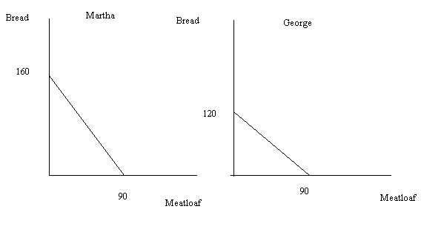
b. George’s opportunity cost of producing one loaf of bread is ¾ meatloaf.
c. George’s opportunity cost of producing one meatloaf is 4/3 loaves of bread.
d. Martha’s opportunity cost of producing one loaf of bread is 9/16 meatloaf.
e. Martha’s opportunity cost of producing one meatloaf is 16/9 loaves of bread.
f. George should produce meatloaf since his opportunity cost of producing meatloaf is lower than is Martha’ s opportunity cost of producing meatloaves.
g. Martha should produce bread since her opportunity cost of producing bread is lower than is George’s opportunity cost of producing loaves of bread.
h. From our work in parts (a) through (d) we know the opportunity cost of producing each of the goods for each of these individuals. We know that the opportunity cost of producing one bread is equal to 9/16 of a meatloaf for Martha and ¾ of a meatloaf for George. Thus, the trading range for one bread will fall between 9/16 of a meatloaf and ¾ of a meatloaf. But, we are interested in the trading range for twenty breads: so multiplying both of these amounts by twenty gives us the trading range of prices in terms of meatloaf for twenty loaves of bread will fall between 45/4 meatloaves and 15 meatloaves.
i. From our work in parts (a) through (d) we know the opportunity cost of producing each of the goods for each of these individuals. We know that the opportunity cost of producing one meatloaf is equal to 4/3 loaves of bread for George and 16/9 loaves of bread for Martha. Thus, the trading range for one meatloaf will fall between 4/3 loaves of bread and 16/9 loaves of bread. But, we are interested in the trading range for thirty meatloaves: so multiplying both of these amounts by thirty gives us the trading range of prices in terms of loaves of bread for thirty meatloaves will fall between 40 loaves of bread and 160/3 loaves of bread.
2. For each of the following scenarios sketch a diagram representing the scenario and then answer the given questions.
a. The market for cell phones is initially in equilibrium. Smart Phone introduces a new phone that provides radically improved services for consumers at the same time that the Federal government decides to implement an excise tax on cell phone producers. Describe the effect of these changes on the equilibrium price and quantity in this market. Assume that this new phone only affects consumers’ tastes and preferences.
b. The market for bicycles is initially in equilibrium. The Surgeon General announces that a study has been done that indicates bicycling is a major contributor to good health for those who bicycle regularly. At the same time the price of gasoline increases due to political unrest in the major oil producing regions of the world. Describe the effect of these changes on the equilibrium price and quantity in this market.
c. The market for soft drinks is initially in equilibrium. The price of sugar, a major ingredient in soft drinks, increases while at the same time, the number of producers in the industry doubles. Describe the effect of these changes on the equilibrium price and quantity in this market.
d. The market for leather jackets is initially in equilibrium. Then, the price of labor used to manufacture the jackets increases. Describe the effect of this change on the equilibrium price and quantity in this market.
Answers:
a. The demand curve for phones will shift to the right due to the improvements in the service available to phone users while the supply curve for phones will shift to the left due to the imposition of the excise tax. The result will be that the equilibrium price of cell phone increases while the equilibrium quantity of cell phones may increase, decrease, or remain the same as the initial equilibrium quantity. Quantity is indeterminate in this example since we do not know the magnitude of the two shifts.
b. Both of these changes will cause the demand curve for bicycles to shift to the right. As oil prices increase people will demand a greater quantity of bicycles at every price since bicycles and oil fueled transportation are substitutes for one another. With the release of the Surgeon General’s report the demand curve for bicycling will shift to the right due to increased demand at every price as a response to the health benefits to be gleaned from bicycling. The equilibrium price and quantity will both increase relative to their initial levels.
c. The increase in the price of sugar will cause the supply curve for soft drinks to shift to the left: at every price a smaller quantity will be supplied due to this increase in input costs. But, the doubling of the number of suppliers will cause the supply curve for soft drinks to shift to the right: at every price a greater quantity will be supplied due to this increase in the number of firms. From the information given it is impossible to know which shift is larger and therefore it is impossible to predict what will happen to the equilibrium price and quantity given these two changes.
d. As the price of labor increases this will cause the supply curve for leather jackets to shift to the left: at every price the quantity supplied will be smaller due to the increase in labor costs. The equilibrium price will increase while the equilibrium quantity will decrease.
3. Suppose that there are only two consumers, Joan and Dave, in the market for widgets. Joan’s demand curve for widgets is given by the equation P = 100 – (1/2)Q while Dave’s demand curve for widgets is given by the equation P = 50 – (1/2)Q. The market supply curve in the market for widgets is given by the equation P = 10 + Q.
a. Draw a series of side by side graphs: in the first graph, depict Joan’s demand curve for widgets; in the second graph, depict Dave’s demand curve for widgets; and in the third graph, depict the market demand curve for widgets. Make sure you label all three graphs completely and carefully; make sure you label any “kink” points with their coordinates as well as labeling any axis intercepts.
b. Write a set of equations and their relevant ranges for the market demand curve.
c. Explain how you will determine which demand curve equation you will need to use in order to find the equilibrium price and quantity in this market.
d. Find the equilibrium price and quantity in this market given the above information.
e. Suppose a price floor of $30 per unit is implemented in this market. What effect will this price floor have on this market? If there is a shortage or surplus, please identify the size of this shortage or surplus.
f. Suppose a price floor of $80 per unit is implemented in this market. What effect will this price floor have on this market? If there is a shortage or surplus, please identify the size of this shortage or surplus.
Answers:
a.
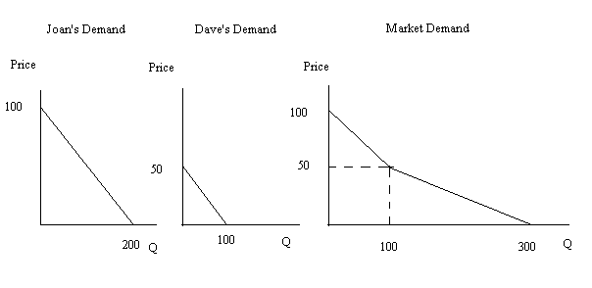
b. For prices greater than or equal to $50 per unit, the demand curve is given by the equation P = 100 – (1/2)Q. For prices less than or equal to $50 per unit, the demand curve is given by the equation P = 75 – (1/4)Q.
c. The market demand curve has two segments: a logical approach to thinking about which segment to use would focus on the idea that there are only three real possibilities. The first possibility is that the solution goes through the upper segment of the demand curve; the second possibility is that the solution is the “kink” in the demand curve; and the third possibility is that the solution goes through the lower segment of the demand curve. The figure below sketches out these ideas.
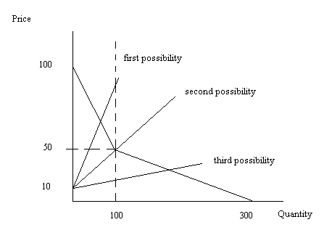
Let’s focus just on the supply curve for a moment: if you put Q = 100 into the supply curve, you find that P = 110. This is clearly a price greater than $50 per unit where the “kink” occurs. This tells us that we need to use the first possibility when solving for the equilibrium price and quantity.
d. From part (c) we know that we are using the market supply curve, P = 10 + Q, and the market demand curve, P = 100 – (1/2)Q, in order to solve for the equilibrium price and quantity. Thus, 10 + Q = 100 – (1/2)Q or Qe = 60 units. Using Q = 60 and the market demand curve, we find that the equilibrium price is $70 per unit.
e. A price floor of $30 per unit will have no effect on this market since the equilibrium price in this market is greater than the price floor amount.
f. A price floor of $80 per unit will result in the market having a surplus since at $80 per unit the quantity demanded is equal to 40 units while the quantity supplied is equal to 70 units. Thus, there will be a surplus of 30 units.
4. Suppose that there are three identical firms in an industry and that each firm’s supply curve is given by the equation P = 10 + Q. Furthermore, suppose that the market demand curve is given by P = 100 – Q.
a. What is the market supply curve given the above information? (Hint: you might find it helpful to draw a sketch to guide your work here.)
b. What is the equilibrium price and quantity in this market?
c. Calculate the value of total revenue in this market.
d. What is the value of consumer surplus in this market?
e. What is the value of producer surplus in this market?
f. What is the value of total surplus in this market?
Answers:
a. Using the firm supply curve we can find several points on that supply curve and that will help us to construct the market supply curve. So, for example when q for the firm is equal to 10 units, the price the firm must receive is $20 per unit. When q for the firm is equal to 20 units, the price the firm must receive is $30 per unit. Since there are three firms this suggests that the points (30, $10) and (60, $20) sit on the market supply curve: with each firm producing 10 units at a price of $20 per unit this means that there are a total of 30 units being produced at that price; with each firm producing 20 units at a price of $20 per unit this means that there are a total of 60 units being produced at that price. Now that we have identified two points on the market supply curve we can write the market supply curve equation: P = 10 + (1/3)Q.
b. Use the market demand curve and the market supply curve to find the equilibrium price and quantity in this market. Thus, 100 – Q = 10 + (1/3)Q and Qe = 67.5 units of the good. Since P = 100 – Q then Pe = 100 – 67.5 = $32.50 per unit.
c. Total revenue is just price times quantity. TR = ($32.50 per unit)(67.5 units) = $2193.75.
d. The value of consumer surplus is equal to (1/2)($100 per unit - $32.50 per unit)(67.5 units) = $2278.125.
e. The value of producer surplus is equal to (1/2)($32.50 per unit - $10 per unit)(67.5 units) = $759.375.
f. The value of total surplus is equal to (1/2)($100 per unit - $10 per unit)(67.5 units) = $3037.50. Alternatively, the value of total surplus is equal to the sum of consumer surplus and producer surplus in this example: TS = CS + PS = $2278.125 + $759.375 = $3037.50. Hint: if you did both of these calculations and came up with different answers then that would tell you that you had made some kind of mistake in your calculations-the values should be the same irrespective of which path you took to get the answer.
5. Suppose you have had five assignments in your chem class this semester. You scores on the five assignments are as follows: 1) 40 out of 50 points; 2) 20 out of 25 points; 3) 20 out of 40 points; 4) 50 out of 50 points; and 5) 80 out of 100 points. You have been told that each assignment has the same weight in the calculation of your grade.
a. Convert each of the above scores to a 100 point scale and then calculate the number of points you have out of a possible 500 points.
b. Suppose that the sixth assignment is going to have forty points and you want your average on a 100 point scale to be equal to 80. What score must you make on the sixth assignment in order for your average to be at this level?
Answers:
a. A table to organize your answers might be helpful here.
Assignment | Raw Score | Score Rescaled to a 100 point scale
#1 | 40/50 | 80/100
#2 | 20/25 | 80/100
#3 | 20/40 | 50/100
#4 | 50/50 | 100/100
#5 | 80/100 | 80/100
#6 | x/40 | 2.5x/100
After the first five assignments you have 390 points out of a possible 500 points once you rescale each assignment to a 100 point scale.
b. We can set this problem up as a simple ratio: (390 + 2.5x)/600= 80/100 and then solve for x. Take a moment to look at this ratio and make sure you understand it. The 390 is the number of points you have on a 500 point scale from part (a) of this problem. The 2.5x is the conversion of the sixth assignment from a 40 point scale to a 100 point scale. The 600 in the denominator is the total number of available points you could get from the six assignments if they were each measured on a 100 point scale. The 80/100 is the average score you would like after the sixth assignments are completed. Solving this ratio for x, we get x = 36. You would need to make a 36 out of 40 points on the sixth assignment in order to have an average of 80 in the class.
6. Joey is taking a class that has ten quizzes over the course of the semester. He has taken five quizzes and his average score on the five quizzes is 78 points on a 100 point scale.
a. Suppose that he takes two more quizzes and scores an 80 on the first of these quizzes and a 90 on the second. What is his average score now?
b. Suppose Joey wants his final quiz score average to be a 83. If he has already taken seven quizzes with the scores discussed earlier, what must his average on the last three quizzes be in order for him to have a final quiz score average of 83 in the class?
Answers:
a. We know that Joey’s average on the first five quizzes is a 78. That implies that Joey has earned 78*5 = 390 points out of a possible 500 points. His scores on the sixth and seventh quizzes will add 170 points to his total points for a grand total of 560 points out of a possible 700 points. His average in the class after seven quizzes will be 560/700 or 80/100. On a 100 point scale his average is an 80.
b. From part (a) we know that Joey has earned 560 points out of a possible 700 points on the first seven quizzes. There are three more quizzes and let’s denote the average score on each of these quizzes as x. Joey will therefore at the end of the ten quizzes have a total number of points of 560 + 3x on the ten quizzes. We can use this information to set up a ratio: (560 + 3x)/1000 = 83/100. The “1000” refers to the total number of points that are available after from the ten quizzes. The “83/100” represents the average that Joey wants to have after the ten quizzes have been taken. Solve for x to find the average score Joey must make on the last three quizzes in order to have an 83 average in the class. The value of x is 90. So, if Joey has an average of 90 on the last three quizzes then his overall average from the ten quizzes will be an 83.
7. Consider the small closed economy of Islandia and its market for bananas. Currently, the domestic demand and supply curves for bananas are given by the following equations:
Domestic Demand: P = 1000 – (1/5)Q
Domestic Supply: P = 200 + (1/15)Q
Furthermore, you know that the world price of bananas is equal to $300 per unit of bananas. Hint: you will likely find it helpful to draw a sketch or several sketches as you proceed with this problem.
a. If Islandia remains a closed economy, what will be the equilibrium price and quantity in the market for bananas in this economy?
b. Suppose Islandia opens the banana market to trade. Will Islandia import or export bananas when it changes its status from a closed economy to an open economy? Explain your answer.
c. Calculate the value of consumer surplus in the banana market when Islandia is a closed economy and the value of consumer surplus in the banana market when Islandia is an open economy. Will domestic consumers be in favor of opening the market to trade? Explain your answer.
d. Calculate the value of producer surplus in the banana market when Islandia is a closed economy and the value of producer surplus in the banana market when Islandia is an open economy. Will domestic producers be in favor of opening the market to trade? Explain your answer.
e. Suppose that the market for bananas in Islandia is open to trade but that the government of Islandia wishes to reduce imports of bananas to 1000 units of bananas through the imposition of a tariff. How big will the tariff need to be in order for Islandia to reach their goal? Explain your answer.
f. How much tariff revenue will be raised with the imposition of the tariff described in part (e)?
g. What is the deadweight loss from the imposition of the tariff described in part (e)?
Answers:
a. To find the equilibrium price and quantity in the closed banana market in Islandia simply use the given supply and demand curves. Thus, 1000 – (1/5)Q = 200 + (1/15)Q or Qe = 3000. Use this quantity and either the domestic demand or domestic supply curve to solve for the equilibrium P: Pe = $400 per unit of bananas.
b. If Islandia opens its banana market to trade, bananas will sell for the world price of $300 per unit of bananas. At this price domestic suppliers will be willing to supply 1500 units of bananas while domestic demanders will demand 3500 units of bananas. There will be an excess demand or shortage of 2000 units of bananas. This shortage will be satisfied by Islandia importing 2000 units of bananas at the world price of $300 per unit of bananas. The sketch below provides an image of this outcome.
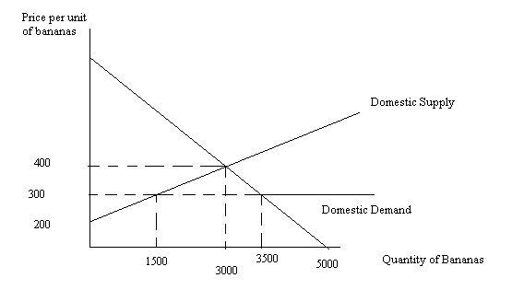
c. Consumer surplus in the banana market when Islandia is closed to trade is equal to (1/2)($1000 per unit - $400 per unit)(3000 units) = $900,000. After the banana market opens to trade consumer surplus is equal to (1/2)($1000 per unit - $300 per unit)(3500 units) = $1,225,000. Opening the banana market to trade is favored by consumers since it results in consumer surplus increasing by $325,000. The graph below shows these two different areas:
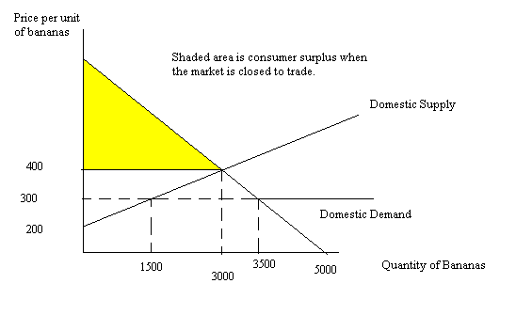
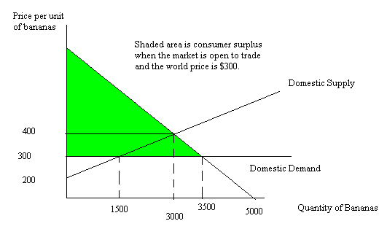
d. Producer surplus in the banana market when Islandia is closed to trade is equal to (1/2)($400 per unit - $200 per unit)(3000 units) = $300,000. After the banana market opens to trade producer surplus is equal to (1/2)($300 per unit - $200 per unit)(1500 units) = $75,000. Opening the banana market to trade is not favored by producers since it results in producer surplus decreasing by $225,000. The graph below shows these two different areas:
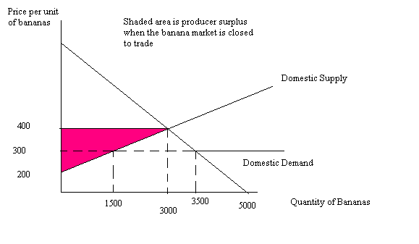
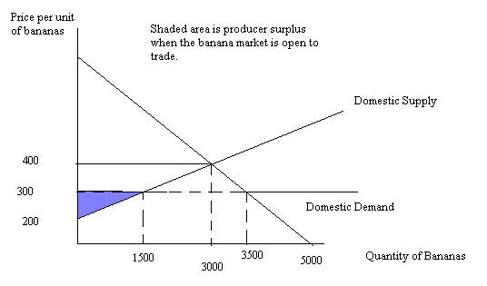
e. From the given information we know we want to find that price and quantity combination that results in 1000 units of bananas being imported into Islandia after the imposition of the tariff. Thus, after the tariff we will have Qs + 1000 = Qd where Qs is the quantity supplied and Qd is the quantity demanded. To use this equation however we will need to rearrange the demand and supply equations so that each is solved in terms of Qd and Qs, respectively. Rewriting the demand equation we have Qd = 5000 – 5P; rewriting the supply equation we have Qs = 15P – 3000. Using these two expressions and the relationship Qs + 1000 = Qd we get 15P – 3000 + 1000 = 5000 – 5P. Solve this equation for the value of P with the tariff. Thus, P = $350 per unit of bananas. Thus, if Islandia imposes a tariff that raises the price of bananas from $300 per unit to $350 per unit this will result in 1000 units of bananas being imported into Islandia. The graph below illustrates this tariff.
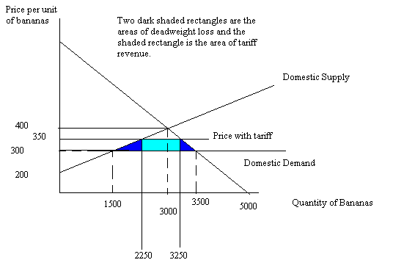
f. Tariff revenue will equal ($50 per unit of bananas imported)(1000 units of bananas imported) = $50,000 in tariff revenue.
g. Deadweight loss is equal to (1/2)($350 per unit - $300 per unit)(2250 units – 1500 units) + (1/2)($350 per unit - $300 per unit)(3500 units – 3250 units) = $25,000.

