Economics 101
Summer 2010
Answers to Homework #2
Due:

This homework is due at the beginning of the class lecture. Make sure that your homework includes your name, section number, and is stapled. There will be no stapler at the class lecture. Submitted homework should be legible, neat, and of professional quality. Please show all necessary work and please be sure that your answer is easy to identify and find.

- Supply and Demand: Basic Review
  - For each of the following situations identify whether there is a shift or a movement along the demand curve, a shift or a movement along the supply curve, the effect on the equilibrium price relative to the initial level, and the effect on the equilibrium quantity relative to the initial level. In the case of a shift identify the direction of the shift (right or left).
Market Under Consideration | Situation | Shift or Movement along the Demand Curve | Shift or Movement along the Supply Curve | Effect on Equilibrium Price | Effect on Equilibrium Quantity
Automobile Market | Price of gas increases | Demand shifts to the left since cars and gas are complementary goods | Movement downward along the supply curve | Price decreases | Quantity decreases
Pizza Market | Price of cheese increases | Movement upward along the demand curve | Supply shifts to the left since the price of an input has risen | Price increases | Quantity decreases
Shampoo Market | Health advisors release study showing danger of frequent hair washing | Demand shifts to the left as consumers shampoo less frequently | Movement downward along the supply curve | Price decreases | Quantity decreases
Oil Market | Oil producing countries form cartel and agree to restrict output | Movement upward along the supply curve | Supply shifts to the left since at every price less oil will be supplied | Price increases | Quantity decreases
Insulation Market | Homeowners granted tax credit for installing home insulation | Demand shifts to the right since consumers will demand more insulation at every price | Movement upward along the supply curve | Price increases | Quantity increases

  - Suppose you are told that the initial demand curve for good X is P = 100 – Q. You are then told that incomes increase in this economy and that good X is a normal good. If you know that the quantity demanded of good X changes by 5 units at every price, what is the equation for the new demand curve?

Answer:
Since good X is a normal good and incomes have increased this implies that the demand curve for good X has shifted to the right. This will be a parallel shift so the slopes of the two demand curves will be the same (-1). Thus, you need only find the y-intercept to write the new demand equation. To find the y-intercept first identify a point that lies on the new demand curve: for example, both (105,0) and (5,100) are points that are on this demand curve. Use one of these points in the equation P = b- Q to find the y-intercept. Thus, P = 105 – Q.

  - Suppose you are told that the initial supply curve for good Y is P = 1000 + 2Q. You are then told that the number of firms in the industry producing good Y increases so that at every price 200 additional units of good Y are now produced. What is the new supply equation for good Y?

Answer:
You are told that the number of firms increases in the industry and that leads to more output at every price: this implies that the supply curve for the market for good Y has shifted to the right. This shift will be a parallel shift so the slopes of the two supply curves will be the same (2). Thus, you need only find the y-intercept to write the new supply equation. To find the y-intercept first identify a point that lies on the new supply curve: for example, since (0,1000) is on the initial supply curve we know that (200,1000) lies on the new supply curve. Use this point in the equation P = b + 2Q to find the y-intercept. Thus, P = 600 + 2Q.

  - Suppose you are told that at the initial demand curve for good Z is P = 100 – 2Q. Furthermore, you are told that demanders tastes and preferences change so that at every price twice as much of good Z is demanded as was demanded initially. What is the equation for the new demand curve? (Hint: Be careful here and really think about this thoroughly-you might want to consider several different (quantity, price) combinations for see what is happening!)

Answer:
The initial demand curve can be graphed with a y-intercept of 100 and an x-intercept of 50. The x-intercept for the new demand curve is simply twice the original x-intercept: the new x-intercept is therefore 100 units. But, what about the y-intercept? When price is equal to 100, 0 units of the good are demanded initially. With the change in tastes and preferences, quantity demanded increases by a factor of two, but multiplying 0 times 2 yields 0. So, the y-intercept does not change with the new demand curve. Thus, the new demand curve contains these two points (0,100) and (100, 0). The new demand curve is therefore P = 100 – Q.

- Supply and Demand: Indeterminancy
  - In the market for corn flakes the price of cardboard used in packing the cereal has risen at the same time that the Surgeon General releases a report detailing the dangers of a diet high in corn products. What happens to the equilibrium price and equilibrium quantity relative to the initial equilibrium before these two changes?

Answer:
The demand for corn flakes will shift to the left and the supply of corn flakes will shift to the left. With this information we know that the equilibrium quantity will decrease while the equilibrium price may increase, decrease, or remain the same relative to its initial level.

  - In the market for bottled water people realize that drinking bottled water causes significant environmental damage due to the waste issues posed by plastic bottles. At the same time, scientists release a study documenting the beneficial effects of drinking water from naturally occurring aquifers (the underground storage place for water that provides the water for bottled water). What happens to the equilibrium price and equilibrium quantity relative to the initial equilibrium before these two changes?

Answer:
The demand curve for bottled water will shift to the left when people take into account the environmental damage, but it will shift to the right what they take into account the health benefits. From the information provided, we do not know the relative size of the two shifts and so we cannot conclude anything about the new equilibrium quantity and new equilibrium price relative to their initial levels.

  - In the market for insulation, people realize that they can substantially reduce the costs of their winter heating bills if their houses are well insulated. At the same time, the government in an effort to increase clean energy jobs passes a law subsidizing insulation producers. What happens to the equilibrium price and equilibrium quantity relative to the initial equilibrium before these two changes?

Answer:
Both the demand and the supply curves for insulation will shift to the right. The equilibrium quantity will increase relative to its initial level while the equilibrium price may increase, decrease or remain the same relative to its initial level.
  - In the market for chocolate, people read that the consumption of chocolate has major health benefits. At the same time, the cost of growing and harvesting cocoa beans increases. What happens to the equilibrium price and equilibrium quantity relative to the initial equilibrium before these two changes?

Answer:
The demand curve for chocolate will shift to the right while the supply curve for chocolate will shift to the left. The new equilibrium price will be greater than its initial level while the new equilibrium quantity may increase, decrease, or remain the same as its initial level.

- Supply and Demand; Price Floors and Price Ceilings
  - Consider the market for ipods. The government decides to impose a price ceiling on ipods. You are told that this is an effective price ceiling. Describe what would make this an effective price ceiling.

Answer:
To be effective, the price ceiling must be set at a price lower than the equilibrium price in this market. If the price ceiling is higher than the equilibrium price then the price ceiling (a maximum price that can be charged for the good) will have no impact on the demand or supply of the good. If the price ceiling is lower than the equilibrium price then the price ceiling will result in excess demand that cannot be eliminated since the price cannot adjust until the quantity demanded equals the quantity supplied.

  - Consider the market for bicycles. The government decides to impose a price floor in this market of $100 per bicycle. If the demand curve for bicycles is P = 1,000 – 2Q and the supply curve for bicycles is P = .5Q, then what is the effect of the price floor on the market for bicycles?

Answer:
First, find the equilibrium in the market without any intervention: P = $200 and Q = 400. A price floor of $100 per bicycle is a minimum price that can be charged for the bicycle. Since this minimum is below the equilibrium price, the price floor is not effective.

  - Consider the market for bicycles. The government decides to impose a price floor in this market of $250 per bicycle. If the demand curve for bicycles is P = 1,000 – 2Q and the supply curve for bicycles is P = .5Q, then what is the effect of the price floor on the market for bicycles?

Answer:
First, find the equilibrium in the market without any intervention: P = $200 and Q = 400. A price floor of $100 per bicycle is a minimum price that can be charged for the bicycle. Since this minimum is above the equilibrium price, the price floor is effective. At a price of $250, 375 bicycles will be demanded while 1500 bicycles will be supplied. There will be an excess supply of bicycles in the market and this excess supply will not be eliminated since price cannot adjust to equate the quantity demanded to the quantity supplied.
- Agricultural Market Interventions
Use the following information about an agricultural market for cotton to answer this set of questions. The market demand curve for cotton is given by the equation P = 200 – .005Q while the market supply curve is given by the equation P = .005Q where P is the price per bale of cotton and Q is number of bales of cotton.
  - What is the equilibrium price and quantity in this market?

Answer:
The equilibrium price in this market is $100 per bale of cotton and the equilibrium quantity is 20,000 bales of cotton.

  - Suppose cotton farmers successfully lobby the legislature to impose a price floor of $150 per bale of cotton. Based on this information provide the answers to the following questions.
    - What price will a bale of cotton sell for once the legislature passes the price floor legislation?
    - How many bales of cotton will be sold to consumers with the imposition of this price floor?
    - How many bales of cotton will be sold to the government with the imposition of this price floor?
    - What is the cost to the government of this program assuming that there are no storage costs?

Answer:
i. A bale of cotton will sell for the price floor price of $150.
ii. To find this answer put $150 in for price in the demand equation to determine the number of bales of cotton consumers want at this price. Thus, the quantity demanded by consumers is equal to 10,000 bales of cotton.
iii. To find this answer put $150 in for price in the supply equation to determine the total number of bales of cotton that suppliers are willing to supply at this price. Thus, quantity supplied equals 30,000 bales of cotton. But, consumers are willing to consume 10,000 bales at a price of $150 leaving the government to purchase the remaining 20,000 bales of cotton.
    - The cost to the government is found by multiplying the number of bales of cotton purchased by the government (30,000) times the price per bale ($150). Or, the cost to the government is $3,000,000.

  - Suppose that instead of a price floor, the legislature imposes a price support program with a guaranteed price of $150 per bale of cotton. Based on this information provide the answers to the following questions.
    - What price will a bale of cotton sell for to consumers once the legislature passes the price support legislation?
    - How many bales of cotton will be sold to consumers with the imposition of this price support?
    - How many bales of cotton will be sold to the government with the imposition of this price support?
    - What is the cost to the government of this program assuming that there are no storage costs?

Answer:
i. Suppliers must first determine how many bales of cotton they are willing to supply at a price support price of $150: from part (b) we know that they are willing to supply 30,000 bales of cotton. Then, they must figure out what price consumers are willing to pay in order to consume 30,000 bales. So, plug 30,000 into the demand equation for Q to find that the price consumers are willing to pay when consuming 30,000 bales of cotton is $50.
ii. Consumers will purchase 30,000 bales of cotton.
iii. With a price support program the government does not buy any of the product. Instead the government subsidizes the price of the product by paying the difference between the target price (in this case $150) and the price consumers are willing to pay ($50 in this case).
    - The cost to the government of this program is the subsidy per unit ($100 per bale of cotton) times the number of bales of cotton (30,000 bales of cotton) or $3,000,000.

  - In this example the programs described in parts (b) and (c) cost the government the same amount. Is this result always true? Explain your answer carefully.
No, the costs may be different and the costs depend on the elasticity of the demand and supply curves: if the curves are relatively inelastic then the cost to the government of the price support program will be less than the cost to the government of the price subsidy program. Figure 1 below illustrates this idea.
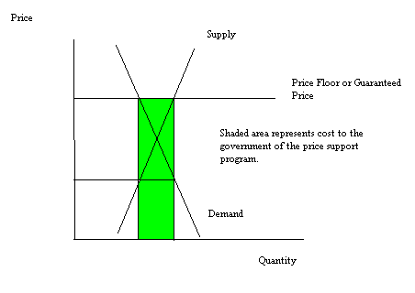

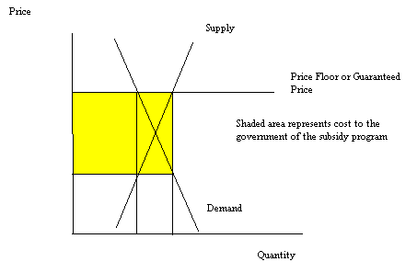
If the curves are relatively elastic then the cost to the government of the price support program will be greater than the cost to the government of the price subsidy program. Figure 2 below illustrates this idea.
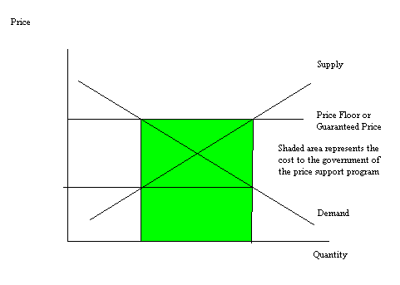
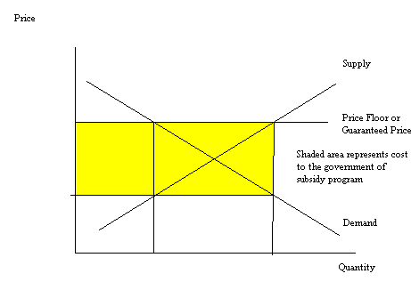

- Tariffs, Quotas and Trade
Use the following information about a small economy to answer this next set of questions. Assume that initially this small economy is closed to trade. You are told that the domestic demand for widgets is given by the equation P = 2500 – 5Qd where Qd is the quantity of domestically demanded widgets and P is the widget price and the domestic supply of widgets is given by the equation P = 20Qs where Qs is the quantity of domestically supplied widgets. The world price of widgets is $1500.
  - Assuming that this economy’s market for widgets is closed to international trade, what is the equilibrium price and quantity of widgets?

Answer:
The equilibrium price is $2000 and the equilibrium quantity is 100 widgets.

  - Suppose this economy opens its widget market to international trade. Describe the impact of this opening of the market for widgets: in your answer describe whether the economy imports or exports widgets, identify the numerical value of these imports or exports, and identify the price of widgets.

Answer:
At the world price of $1500, the domestic demand for widgets is equal to 200 widgets while the domestic supply of widgets is equal to 75 widgets. Therefore, 125 widgets will be imported into this economy.
  - Suppose that domestic producers of widgets go to Congress and successfully lobby for the imposition of a quota for the widget markets. This quota results in the price of widgets in this small open economy increasing to $1800. What is the amount of the quota given this information?

Answer:
Since we know that the price of widgets has risen to $1800 with the imposition of the quota we can use this information to identify how many units will be domestically demanded at this price and how many units will be domestically supplied at this price. When the price is $1800, domestic consumers demand 140 widgets. When the price is $1800, domestic producers supply 90 units. The difference between these two levels is the quantity of imports needed to satisfy domestic demand at a price of $1800. Thus, 50 widgets will be imported and therefore the quota must be 50 widgets.

  - For the quota described in part (c) compute the value of consumer surplus with the quota, the value of producer surplus with the quota, the value of license holder revenue, and the deadweight loss due to the quota.

Answer:
Consumer surplus with the quota is equal to (1/2)(700)(140) = $49,000
Producer surplus with the quota is equal to (1/2)(1800)(90) = $81,000
License Holder Revenue = (300)(50) = $15,000
Deadweight Loss with the quota = (1/2)(300)(15) + (1/2)(300)(60) = $11,250

  - Suppose that instead of a quota Congress implements a tariff in the widget market. Suppose this tariff results in 60 widgets being imported into this market? What is the price of widgets in the small economy with the imposition of the tariff?

Answer:
To find the price with the tariff you need to first realize that Qd – Qs = 60 in the widget market. Then, substitute 500 – (1/5)P for Qd and (1/20)P for Qs to solve for the price. Thus, 500 – (1/5)P – (1/20)P = 60 or P = $1760. Check to see that at a price of $1760 sixty widgets will be imported. Thus, when P = $1760, the quantity demanded domestically is equal to 148 widgets while the quantity supplied domestically is equal to 88 widgets: this implies that 60 widgets will be imported at this price.

  - For the tariff described in part (e) compute the value of consumer surplus with the tariff, the value of producer surplus with the tariff, the tax revenue from the tariff, and the deadweight loss due to the tariff.

Answer:
Consumer surplus with the tariff is equal to (1/2)(2500- 1760)(148) = $54,760
Producer surplus with the tariff is equal to (1/2)(1760)(88) = $77,440
Tariff Revenue = (260)(60) = $15, 600
Deadweight Loss due to the Tariff = (1/2)(260)(13) + (1/2)(260)(52) = $8450

- Excise Tax
Use the following information to answer this question. Suppose there is a market for bicycles in Wheelerville that can be described by the following demand and supply equations:
Demand: Q = 200 – (1/5)P
Supply: Q = (1/5)P – 40
Where Q refers to the quantity of bicycles and P is the price of a bicycle.

  - What is the equilibrium price and equilibrium quantity of bicycles in Wheelerville? Calculate the value of consumer surplus, producer surplus, and total surplus in this market.

Answer:
The equilibrium price is $600 and the equilibrium quantity is 80 bicycles. The value of consumer surplus is equal to (1/2)($1000/bike - $600/bike)(80 bikes) = $16,000. The value of producer surplus is equal to (1/2)($600/bike - $200/bike)(80 bikes) = $16,000. The value of total surplus is equal to the sum of consumer surplus and producer surplus in this case and is therefore equal to $32,000.

  - Suppose an excise tax of $50 per bicycle is imposed on bicycle producers in this market? What is the new equilibrium price and equilibrium quantity of bicycles in this market with the imposition of the excise tax? What is the net price received by bike producers when this excise tax is implemented? What is the economic burden of the excise tax on consumers (consumer tax incidence)? What is the economic burden of the excise tax on producers (producer tax incidence)?

Answer:
The new supply curve with the excise tax is Q = (1/5)P – 50. Using this equation and the original demand curve you can find the equilibrium price and equilibrium quantity. The equilibrium price is $625 and the equilibrium quantity is 75 bicycles. The net price is $625 - $50 or $575. The consumer tax incidence is equal to ($25/bike)(75 bikes) = $1875. The producer tax incidence is equal to ($25/bike)(75 bikes) = $1875.

  - Given the excise tax described in part (b), calculate the value of the excise tax revenue. What is the value of producer surplus with the excise tax? What is the value of consumer surplus with the excise tax? What is the deadweight loss due to the imposition of the excise tax?

Answer:
Excise tax revenue is equal to the sum of consumer tax incidence plus producer tax incidence or $3750. Or, you can calculate the excise tax revenue as the (tax per unit)(number of units) or ($50/bike)(75 bikes) = $3750. The value of consumer surplus with the excise tax is equal to (1/2)($1000/bike - $625/bike)(75 bikes) = $14,062.50. The value of producer surplus with the excise tax is equal to (1/2)($575/bike - $200/bike)(75 bikes) = $14,062.50. Deadweight Loss can be calculated as the difference between the original Total Surplus minus the sum of Consumer Tax Incidence, Producer Tax Incidence, Consumer Surplus with the Excise Tax, and Producer Surplus with the Excise Tax. Or, $32,000 – ($1875 + $1875 + $14,062.50 + $14,062.50) = $125. Or, you can calculate Deadweight Loss as being equal to (1/2)($625/bike - $575/bike)(80 bikes – 75 bikes) = $125.

