Economics 101
Homework #2 Answer Key
Fall 2008
1.
- Demand for Frosted Flakes shifts to the left, and this shift results in the equilibrium price and the equilibrium quantity decreasing.
- Demand for Frosted Flakes shifts to the right, and this shift results in the equilibrium price and the equilibrium quantity increasing.
- Supply of Frosted Flakes shifts to the right, and this shift results in the equilibrium price decreasing while the equilibrium quantity increases.
- Demand for Frosted Flakes shifts to the left, and this shift results in the equilibrium price and the equilibrium quantity decreasing.
- An effective price floor will raise the price of Frosted Flakes above the equilibrium price: at the imposed price floor price the quantity demanded will be lower than it was initially while the quantity supplied will be greater than it was initially.
- Supply of Frosted Flakes shifts to the left, and this shift results in the equilibrium price increasing while the equilibrium quantity decreases.
- Demand for Frosted Flakes shifts to the left, and this shift results in the equilibrium price and the equilibrium quantity decreasing.
- An effective price ceiling will lower the price of Frosted Flakes below the equilibrium price: at the imposed price ceiling price the quantity demanded will be greater than it was initially while the quantity supplied will be lower than it was initially.

2.
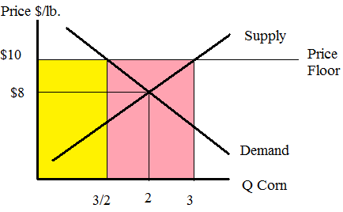

Yellow is the cost to consumers and pink is the cost to the government
- The equilibrium quantity is 2 pounds of corn and the equilibrium price is $8 per pound of corn. To find this equilibrium set the quantity supplied equal to the quantity demanded.
- 3 pounds of corn will be supplied with the imposition of the price floor.
  - pounds of corn will be demanded by consumers with the imposition of the price floor.
The government will purchase 1.5 pounds of corn.
Cost to Government (excluding storage costs) = (3-3/2)*(10-0) =$15
Total cost Government (including storage costs) = $15 + ($2/pound)(1.5 pounds) = $18
- Cost to Consumers = (3/2-0)*(10-0)=$15
- 3 pounds of corn will be supplied with the imposition of the price subsidy program.
3 pounds of corn will be demanded by consumers with the imposition of the price subsidy.
The government will purchase 0 pounds of corn with the price subsidy program.
Cost to Government = ($10/pound - $4/pound)(3 pounds) = $18
Cost to Consumers = ($4/pound)(3 pounds) = $12
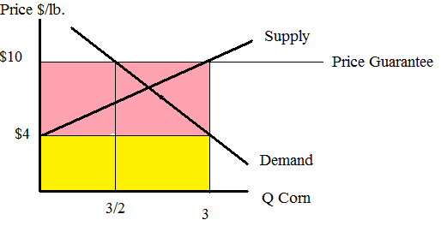
Pink is cost to government and yellow is the cost to consumers.

3. a.

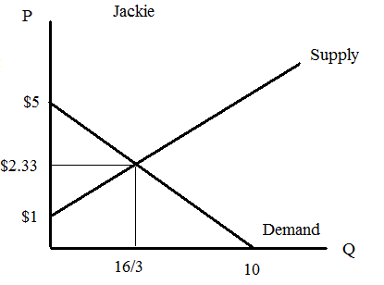
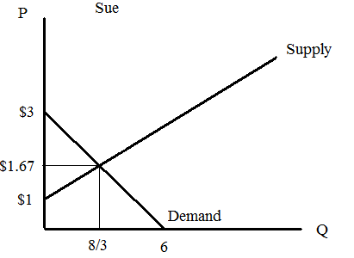

b. Q=16/3, P=$7/3=$2.33
c.
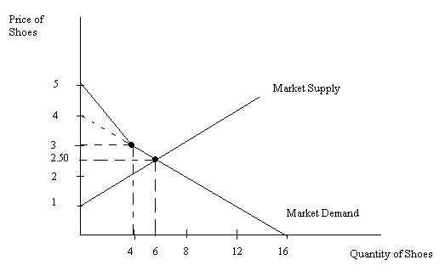
d.Q=10-2P for P>3, Q= 16-4P for P≤3, Equilibrium: P=$2.50, Q=6
4.
a. In Country A, 1 worker can produce either 1/20 of a flat screen TV or 1/5of an iPod.
Country A has 100 workers per day so it can produce: 100/20 = 5 flat screen TVs or 100/5 = 20 iPods or some combination of these two goods that lies on the line between these two points.
In Country B, 1 worker can produce either 1/10 of a flat screen TV or 1/5 of an iPod.
Country B has 100 workers per day so it can produce: 100/10 = 10 flat screen TVs or 100/5 = 20 iPods or some combination of these two goods that lies on the line between these two points.
Use this information to draw the two individual PPF’s.
Flat screen TVs
iPods
20
5
PPF_{A}
Flat screen TVs
iPods
10
20
PPF_{B}
Graph 4a:

Flat screen TVs
iPods
10
•
20
15
40
PPF_{combined}
Graph 4k

Graph 4a:

b. Country B can produce up to 10 flat screen TVs per day while Country A can only produce a maximum of 5. Therefore Country B has the absolute advantage in flat screen TV production.
c. Country B can produce up to 20 iPods per day and Country A can also produce a maximum of 20 iPods per day. Therefore neither of them has an absolute advantage in iPod production.
d. Recall: the opportunity cost of the good on the horizontal axis is = –(slope of PPF).
The slope is of the PPF in country A is: -20/5 = -4
So the opportunity cost of producing a flat screen TV in country A is: 4 iPods.
e. The slope is of the PPF in country B is: -20/10 = -2
So the opportunity cost of producing a flat screen TV in country B is: 2 iPods.
f. Recall: the opp. cost of the good on the vertical axis is the reciprocal of the opp. cost of other good. The opp. cost of a flat screen TV in Country A was 4 iPods, so the opp. cost of an iPod is ¼ flat screen TVs.

g. The opp. cost of a flat screen TV in Country B was 2 iPods so the opp. cost of an iPod is: ½ flat screen TVs.

h. In Country A it costs 4 iPods to produce a flat screen TV. In Country B it costs 2 iPods to produce a flat screen TV. Therefore Country B has the comparative advantage in producing flat screen TVs.

i. If Country B has the comparative advantage in producing flat screen TVs then Country A must have the comparative advantage in producing iPods.

j. Each country will produce the good for which it has the comparative advantage. Country B will specialize in the production of flat screen TVs since that is its comparative advantage. It costs Country B 2 iPods to produce a flat screen TV, so it won’t trade for anything less than 2 iPods. Country A could produce its own flat screen TVs at a cost of 4 iPods so it won’t pay any more than that. Therefore the price won’t be less than 2 iPods and it won’t be greater than 4 iPods.

k. How to derive the combined PPF: If both countries produced only iPods, country A would produce 20 iPods and country B would produce 20 iPods, for a total iPod production of 40 ipods. Now let’s suppose that 1 flat screen will be produced, and the rest of goods will be iPods. Which country will produce this first flat screen TV? Country B will produce the first flat screen TV because it has a comparative advantage in producing flat screen TVs. (Note: If is possible to have the first flat screen TV produced by country A, but this point would NOT be efficient and therefore would not be on the PPF_{combined}). If second flat screen TV was produce, which country would manufacture it? Again country B, because it has a comparative advantage in producing flat screen TVs. We can continue this argument until we get to the point (10,20). Country B can only produce a maximum of 10 flat screen TVs, so if 11th (12th, 13th etc.) flat screen TV is produced, it must be manufactured by country A. That’s why we get the a “kink” at point (10,20). Note that the upper part of PPF_{combined} is parallel with PPF_{B}, and the lower part of PPF_{combined} is parallel with PPF_{A}.
Note: We could have started this argument from horizontal axis and it would lead us to the same result: if both countries produce only flat screen TVs, they will produce 5+10 = 15 flat screen TVs total. If we start producing iPods, country A will be the one who will produce the 1st (2nd, 3rd, etc.) iPod, because it has a comparative in producing iPods. Country A cannot produce more than 20 iPods, so the 21st (22nd etc.) iPod must be produced by country B.

5. a.
D
Q
S
4
P [$]
2
•
8
4
CS
PS
16
6

b. Consumer surplus equals (1/2)*(2 jars of peanut butter)*($16/jar of peanut butter - $8/jar of peanut butter) = $ 8. Producer surplus equals (1/2)*(2 jars of peanut butter)*(
$8/jar of peanut butter - $4/jar of peanut butter) = $ 4.
c. An excise tax causes a shift in the supply curve (we can treat it as an increase in input costs for the firm, since they have to pay $3 more for each unit that they produce). Thus the new supply curve is P=(2Q_{S}+4)+3=2Q_{S}+7. The demand curve does not change. The new equilibrium is at a price of $10 and a quantity of 1.5. The price tells us how much consumers have to pay.

D
Q
S
4
P [$]
2
•
8
4
16
S₂
7
1.5
10
A
C
B
F
G
H

Government tax revenue with the excise tax = rectangle A + rectangle C
Consumer surplus with the excise tax = triangle G
Producer surplus with the excise tax = triangle H
Deadweight loss with the excise tax = triangle B + triangle F

d.
Government tax revenue with the excise tax = rectangle A + rectangle C = ($10/jar of peanut butter - $7/jar of peanut butter)(1.5 jars of peanut butter) = $ 4.5
Consumer surplus with the excise tax = triangle G = (1/2)($16/jar of peanut butter - $10/jar of peanut butter) (1.5 jars of peanut butter) = $ 4.5
Producer surplus with the excise tax = triangle H = (1/2)($7/jar of peanut butter - $4/jar of peanut butter)(1.5 jars of peanut butter) = $ 2.25
Deadweight loss with the excise tax = triangle B + triangle F = (1/2)($10/jar of peanut butter - $7/jar of peanut butter)(2 jars of peanut butter – 1.5 jars of peanut butter) = $ 0.75

