Economics 101
Summer 2012
Answers to Homework #1
Due 5/31/12

Directions: The homework will be collected in a box before the lecture. Please place your name, TA name and section number on top of the homework (legibly). Make sure you write your name as it appears on your ID so that you can receive the correct grade. Late homework will not be accepted so make plans ahead of time. Please show your work. Good luck!

Please realize that you are essentially creating “your brand” when you submit this homework. Do you want your homework to convey that you are competent, careful, professional? Or, do you want to convey the image that you are careless, sloppy, and less than professional. For the rest of your life you will be creating your brand: please think about what you are saying about yourself when you do any work for someone else!

1. For each of the following examples take the given information and write an equation in slope intercept form. Show all your work and NOT just your final answer.
a. The points (x, y) = (10,0) and (5, 15) both sit on the same line.
b. The points (x, y) = (0, 10) and (5, 15) both sit on the same line.
c. The slope of the line is -2 and the line contains the point (x, y) = (-20, -10).
d. The reciprocal of the slope for the line is 1/5 and the line contains the point (x, y) = (10, 5).
e. The point (x, y) = (5, 10) is on the line and furthermore you know that each time x increases by 2 units, y increases by 3 units.
f. The point (x, y) = (100, 200) is on the line and furthermore you know that each time x increases by 2 units, y decreases by 4 units.

Answer:
a. m = (0 – 15)/(10 – 5) = -3
y = mx + b
0 = (-3)(10) + b
b = 30
y = 30 – 3x

b. m = (10 – 15)/(0 – 5) = 1
y = mx + b
10 = 0 + b
b = 10
y = x + 10

c. y = mx + b
y = -2x + b
-10 = (-2)(-20) + b
b = -50
y = (-2)x – 50

d. 1/m = 1/5 and that implies that m = 5
y = mx + b
y = 5x + b
5 = (5)(10) + b
b = -45
y = 5x -45

e. m = (change in y)/(change in x) = 3/2
y = (3/2)x + b
10 = (3/2)(5) + b
b = 5/2 = 2.5
y = (3/2)x + 2.5

f. m = (change in y)/(change in x) = -2
y = (-2)x + b
200 = (-2)(100) + b
b = 400
y = 400 – 2x

2. Find the solution (x, y) for each set of equations. Show your work and NOT just your final answer.
a. y = 10 – x
y = 6

b. y = 10 – x
x = 4

c. y = 10 – x
x = y – 2

d. y = 10 – x
y = 20 – 3x

Answers:
a. 6 = 10 – x
x = 4
(x, y) = (4, 6)

b. y = 10 – 4
y = 6
(x, y) = (4, 6)

c. rewrite x = y – 2 as y = x + 2
10 – x = x + 2
2x = 8
x = 4
y = 10 – 4 = 6
(x, y) = (8, 6)

d. 10 – x = 20 – 3x
2x = 10
x = 5
y = 10 – 5 = 5
(x, y) = (5, 5)

3. You are provided the following figure and given another equation, y = 2x + 1. Find the solution (x, y) given this information. (Hint: do NOT expect nice numbers! Do try to work this without a calculator though-it will be good practice.)
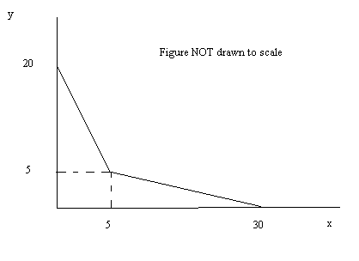
Answer:
There are three possibilities in general about the solution to this question. The given equation might cross the top segment in the drawn picture, it might cross through the common point in the drawn picture, or it might cross the bottom segment in the drawn picture. The graph below sketches out three possible representations of this idea.

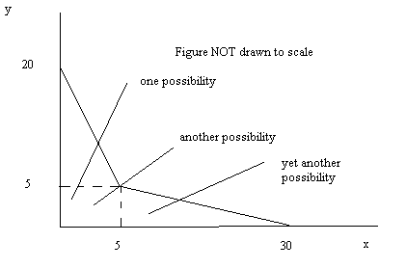

So, the challenge is figuring out which of these possibilities is the correct one. We need to eliminate two of these three possibilities. We know that point (5, 5) sits on both lines drawn in this graph. So, when x = 5, what is y’s value in the equation y = 2x + 1? Y = 2(5) + 1 = 11. So the first possibility is the correct one since the y value in the equation when x = 5 is greater than 5. To find (x, y) we need the equation for the upper line segment in the graph. We know that this line includes (0, 20) and (5, 5). The slope is therefore m = -3 and the equation is y = -3x + 20. Use this equation and the given equation to find the solution: (x, y) = (19/5, 8.6).

4. a. Suppose you are given a line described by the equation y = 100 – 2x and you are told that the x value has increased by 50 units at every y value. What is the equation for the new line? Show your work.
b. Suppose you are given a line described by the equation y = 100 – 2x and you are told that the x value has doubled at every y value. What is the equation for the new line? Show your work.
c. Suppose you are given a line described by the equation y = 100 – 2x and you are told that the y value has increased by 50 units at every x value. What is the equation for the new line? Show your work.

Answer:
It is helpful to have a sketch to guide your work here. The initial line is given in the graph below.
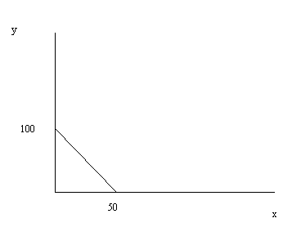
a. The line has shifted in a parallel fashion to the right so the slope is unchanged but the new line contains the point (100, 0). The new equation is y = -2x + b and you can find the value of b by substituting in the point that lies on the new line. Thus, 0 = -2(100) + b or b = 200. The new equation is y = 200 – 2x. The graph below represents the new line.
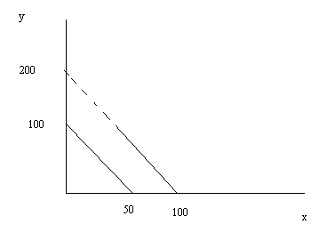
b. The new line has the same y-intercept as the initial line but the x-intercept is now 100 instead of 50. Therefore the new line has slope = -1 and the equation for the new line is y = 100 – x. The diagram below illustrates this new line.
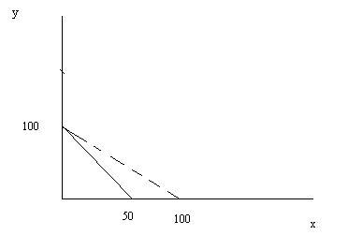
c. The line has shifted in a parallel fashion to the right so the slope is unchanged and the new line has y-intercept of 150. The new equation is y = -2x + 150. The graph below illustrates this new line.
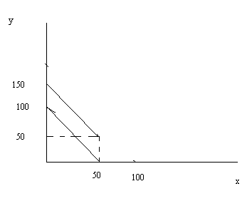

5. The average of 5 numbers is 52. Suppose five more numbers are included in the set of numbers and these five numbers equal 0, 100, 48, 90, and 50. What is the new average? Explain the steps you took to get your answer.

Answer:
The average of the first five numbers is 52. To find this average we know that we took the sum of the five numbers and divided by 5. Thus, the sum of the first five numbers must be equal to 5(52) = 260. The sum of the second five numbers is 0 + 100 + 48 + 90 + 50 = 288. The sum of all ten numbers is 288 + 260 or 548. The average of the ten numbers is 548/10 = 54.8.

6. There are three midterms in the class Alice is taking. The first midterm counts as 20% of her grade, the second midterm counts as 30% of her grade, and the third midterm counts as 50% of her grade. Each exam has 100 points and Alice knows that her weighted average must be equal to 90 in order to earn an “A” in the class. Suppose Alice made an 85 on the first exam and a 92 on the second exam. What is the minimum score Alice must make on her third exam in order to get an “A” in the class? Fully explain your answer. Provide an answer two places past the decimal.

Answer:
.2(midterm 1) + .3(midterm 2) + .5(midterm 3) = 90
.2(85) + .3(92) + .5(x) = 90
17.0 + 27.6 + .5x = 90
.5x = 45.4
X = 90.8

7. There are three midterms in the class Molly is taking. The first midterm counts as 20% of her grade, the second midterm counts as 30% of her grade, and the third midterm counts as 50% of her grade. The first midterm had 50 points and Molly made a 40 out of 50 points. The second exam had 60 points and Molly made a 50 out of 60 points on it. The third exam has a total of 75 points on it. To earn an “A” in the class Molly must have a weighted average of 90 on a 100 point scale from the three midterms. What is the minimum score Molly must make on her third midterm in order to get an “A” in the class? Fully explain your answer. Please provide an answer two places past the decimal.

Answer:
First let’s convert the first and second midterm scores to a 100 point scale:

First Midterm:
40/50 = x/100
x= 80 points on a 100 point exam
Second Midterm:
50/60 = y/100
y = 83.33 on a 100 point exam

To get an “A” in the class Molly needs a weighted average of 90. Or,
.2(80) + .3(83.33) + .5(z) = 90
.5z = 49
z = 98.00

But this is a 98 out of 100 points, so we need to calculate what this score would be on a 75 point test. Thus,
Score/75 = 98/100
Score = 73.50

8. Use the information in the table below to answer this set of questions. Suppose that each of the following points in the table is a point on the production possibility frontier for Econoland. Furthermore suppose that the PPF for Econoland is linear between each of these combinations-for example, the PPF is linear between points A and B, between points B and C, etc.
Combination | Pounds of Butter | Number of Guns
A | 1000 | 0
B | 800 | 110
C | 600 | 150
D | 400 | 175
E | 0 | 200
a. Draw a graph of Econoland’s PPF measuring guns on the vertical axis and butter on the horizontal axis. Label both axes as well as combinations A, B, C, D, and E.
b. Given the above information, what is the opportunity cost of producing 200 more pounds of butter if Econoland is currently producing at point C?
c. Given the above information, what is the opportunity cost of producing 200 more pounds of butter if Econoland is currently producing at point B?
d. Given the above information, what is the opportunity cost of producing 100 more pounds of butter if Econoland is currently producing at point D?
e. Given the above information, what is the opportunity cost of producing one additional gun if Econoland is currently producing at point B?
f. Given the above information, what is the opportunity cost of producing one additional gun if Econoland is currently producing at point D?

Answer:
a.
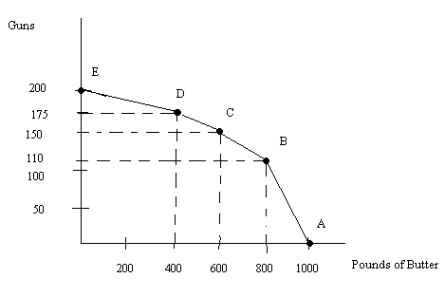
b. 150-110=40 guns
c. 110 guns
d. 12.5 guns
e. 5 pounds of butter
f. 16 pounds of butter

9. It takes Joe 5 hours to wash the family’s clothes and 3 hours to cook the family dinner. It takes Sue 2 hours to cook the family dinner and 4 hours to wash the family’s clothes. Both Joe and Sue have a total of sixty hours a month they can devote to these two tasks. (Assume that their PPFs are linear and that they can divide their time between these two tasks.) Use this information to help Joe and Sue answer these questions about their production within their family.
a. If Joe produces only laundry how many times can he wash clothes in an entire month?
b. If Joe produces only dinners how many family dinners can he produce in an entire month?
c. If Sue produces only laundry how many times can she wash clothes in an entire month?
d. If Sue produces only dinners how many family dinners can she produce in an entire month?
e. Who has the absolute advantage in doing laundry? Explain your answer.
f. Who has the absolute advantage in making family dinners? Explain your answer.
g. Who has the comparative advantage in doing laundry? Explain your answer.
h. Who has the comparative advantage in preparing family dinners? Explain your answer.
i. Construct the joint PPF for Joe and Sue measuring laundry on the vertical axis and family dinners on the horizontal axis.
j. What is the range of trading prices in terms of family dinners that both Joe and Sue will accept for 10 laundry times?

Answers:
a. If Joe devotes all of his available time to producing laundry he can do laundry 12 times in the month since 60 hours of time divided by 5 hours per laundry yields 12 completed laundries for Joe.
b. If Joe devotes all of his available time to producing family dinners he can produce 20 family dinners in the month since 60 hours of time divided by 3 hours per family dinner yields 20 completed family dinners for Joe.
c. Sue using the same logic as in parts (a) and (b) can produce 15 laundries per month.
d. Sue using the same logic as in parts (a), (b), and (c) can produce 30 family dinners per month.
e. Sue has the absolute advantage in producing laundries since she can produce 15 while Joe can only produce 12.
f. Sue has the absolute advantage in producing family dinners since she can produce 30 while Joe can only produce 20.
g. Joe has the comparative advantage in producing laundry since his opportunity cost of producing 1 laundry is 10/6 of a family dinner while Sue’s opportunity cost of producing 1 laundry is 2 family dinners.
h. Sue has the comparative advantage in producing family dinners since her opportunity cost of producing 1 family dinner is ½ of a laundry while Joe’s opportunity cost of producing 1 family dinner is 6/10 of a laundry.
i.
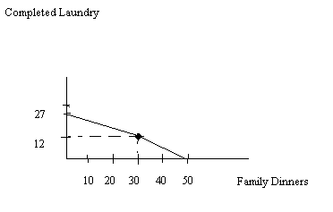
j. The trading range of prices for 10 laundries is between 16.67 family dinners and 20 family dinners.

