Economics 101
Summer 2009
Answers to Homework #1
Due Monday, June 1, 2009

Directions: The homework will be collected in a box before the lecture. Make sure you write your name as it appears on your ID so that you can receive the correct grade. Late homework will not be accepted so make plans ahead of time.

- Identify whether the following statements are normative (N) or positive (P).
  - Ben Bernanke as Chair of the Federal Reserve has pursued new policy interventions intended to help restore the functioning of the credit markets.
This is a positive statement since it can be evaluated as to its truthfulness: as a matter of record this is both a positive and a true statement.
  - If sufficient numbers of people lose their jobs this will likely cause the overall level of prices in the economy to fall.
This statement is positive since it can be tested and proven either true or false.
  - High levels of unemployment are a far more serious issue than high levels of inflation.
This statement is normative since it is a value judgment rather than an objective statement.
  - Gasoline prices always rise during the summer months.
This is a positive statement since it can be tested and proven either true or false. Although it may seem like an opinion and therefore a subjective statement, it is a statement that can be subjected to proof.

- Point A with coordinates (X = 4, Y = 6) and point B with coordinates (X = 10, Y = 12) belong to a straight line. Let Y be on the vertical axis and X on the horizontal axis.
  - Draw a graph of this straight line.
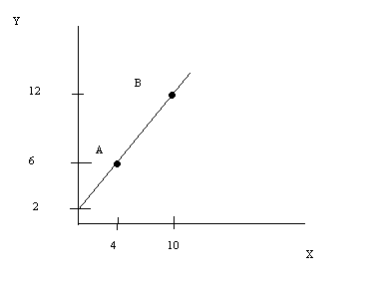
  - Give the equation of this line.
Y = X + 2
  - Find the slope of the line.
Slope = 1
  - Indicate the X and Y axis intercepts for this line.
X-intercept is at (-2,0) and Y-intercept is at (0,2)
Suppose there is a second line that has a slope of -1 and includes the point (5,5).
e. What is the equation for this line?
Y = 10 - X
f. Given these two lines, what are the equilibrium values for X and Y?
X = 4, Y = 6

- Graph the following sets of equations. Each set of equations should be on its own graph and each graph should have the x and y axis labeled, the solution for the two equations identified (i.e., what value of x and y will satisfy both equations) as X and Y.
  - Y = X - 2, Y = 20 - X
X = 9, Y = 7
  - Y = - 2X + 10, Y = 8X
X = 1, Y = 8
  - X = 3Y + 10, X = 30 - 2Y
X = 22, Y = 4
  - X = 2Y + 2, X = 12 - 3Y
X = 6, Y = 2

- A factory of 2000 workers produces textbooks and paper tablets. Each worker can produce either 20 textbooks per hour or 100 paper tablets per hour. Assume that each worker works 40 hours a week.
  - Using a week as your time period, draw the PPF for this factory and label it PPF₁. In your graph measure textbooks (TB) on the horizontal axis and paper tablets (PT) on the vertical axis.
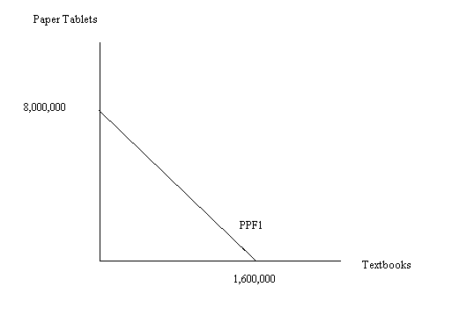
  - Find the equation of the PPF. Write this equation in slope-intercept form.
PT = 8,000,000 – 5TB
  - What is the opportunity cost of producing one textbook?
The opportunity cost of producing one textbook is 5 paper tablets: to produce one textbook you must give up producing 5 paper tablets.
  - What is the opportunity cost of producing one paper tablet?
The opportunity cost of producing one paper table is 1/5 textbook: to produce one paper table you must give up producing 1/5 of a textbook.
  - Is there a relationship between the opportunity cost and the slope of the PPF? Explain this relationship.
Yes, the slope of the PPF tells you how many units of the good measured on the y-axis you must give up in order to get one unit of the good measured on the x-axis. For example, in the above graph the slope of the production possibility frontier is -5: this tells us that we must give up 5 units of the good measured on the y-axis, paper tablets, in order to get one unit of the good measured on the x-axis, textbooks.
  - Contrast and compare the relationship of the slope and opportunity cost of a linear PPF and a bowed-out from the origin PPF.
A linear PPF has constant opportunity cost since its slope does not change as you move along the PPF. A bowed-out from the origin PPF illustrates the law of increasing opportunity cost: as you move down the PPF the opportunity cost of getting each additional unit of the good measured on the x-axis is increasing; or, as you move up the PPF the opportunity cost of getting each additional unit of the good measured on the y-axis is increasing. The opportunity cost is not constant for a bowed-out from the origin PPF since the slope of this PPF varies as you move along the curve.
  - Suppose the workers invent some new method to produce textbooks. With the implementation of the new method, each worker can produce 30 textbooks per hour instead of 20 textbooks per hour. Draw the PPF (using a week as your time period) and label it PPF₂. Write the equation for PPF₂ in slope-intercept form. What does this example suggest about the relationship between the PPF and technological improvements?
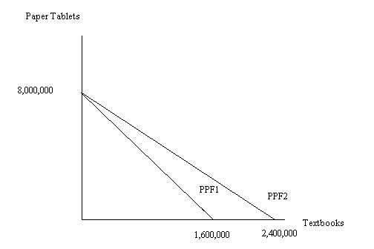

PT = 8,000,000 – 3.3TB
Technological improvements shift the PPF outward from the origin implying that it is now possible to produce more output than was initially possible.

Use the following table to answer question 5.

Units produced in one week

 | bicycles | sodas
Smalltown | 60 | 30
Largetown | 3000 | 9000

- The Smalltown and Largetown both produce bicycles and soda. These goods are produced using labor only. The table above shows how many units are produced in each town during a week. We are assuming that the PPFs for both towns are linear.
  - Draw the production possibilities frontiers (PPFs) for Smalltown and Largetown with bicycles on the horizontal axis and sodas on the vertical axis. Use two different graphs for your representation.
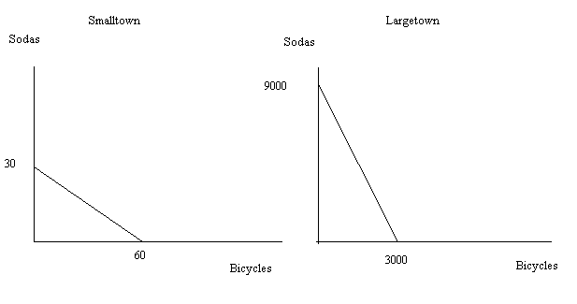
  - What is the opportunity cost of producing one soda for Smalltown? What is the opportunity cost of producing one soda for Largetown?
The opportunity cost of producing one soda for Smalltown is 2 bicycles and the opportunity cost of producing one soda for Largetown is 1/3 bicycle.
  - What is the opportunity cost of producing one bicycle for Smalltown? What is the opportunity cost of producing one bicycle for Largetown?
The opportunity cost of producing one bicycle for Smalltown is ½ soda and the opportunity cost of producing one bicycle for Largetown is 3 sodas.
  - Which town has the absolute advantage in producing sodas? And which town has the absolute advantage in producing bicycles?
Largetown has the absolute advantage in producing both sodas and bicycles since it can absolutely produce more bicycles and sodas than can Smalltown.
  - Which town has the comparative advantage in producing sodas? And which town has the comparative advantage in producing bicycles?
Smalltown has the comparative advantage in producing bicycles since it must give up only ½ soda to produce a bike while Largetown must give up 3 sodas to produce a bike. Largetown has the comparative advantage in producing sodas since it must give up only 1/3 bicycle to produce a soda while Smalltown must give up 2 bicycles to produce a soda.
  - What is the range of acceptable prices (measured in terms of bicycles) for soda if Smalltown and Largetown both specialize according to their comparative advantage and then trade with one another?
With specialization according to comparative advantage and trade, a soda will trade for a price that is between 1/3 bicycle and 2 bicycles.
  - What is the range of acceptable prices (measured in terms of sodas) for bicycles if Smalltown and Largetown both specialize according to their comparative advantage and then trade with one another?
With specialization according to comparative advantage and trade, a bicycle will trade for a price that is between ½ soda and 3 sodas.

- For each of the following situations determine the effect of this change on the equilibrium price and quantity in the given market. Assume that the given change is the only change that occurs in the market.
  - People’s tastes and preferences change in favor of chocolate ice cream. What happens to the equilibrium price and quantity in the market for chocolate ice cream?
The demand curve shifts to the right and this causes the equilibrium price and quantity to increase.
  - The price of chocolate ice cream increases. What happens to the equilibrium price and quantity in the market for vanilla ice cream? Assume chocolate and vanilla ice cream are substitutes for one another.
The demand curve for vanilla ice cream shifts to the right due to the increase in the price of chocolate ice cream. This increase in the price of chocolate ice cream will cause consumers to demand more vanilla ice cream at every price. The equilibrium quantity and price of vanilla ice cream will increase.
  - The price of chocolate ice cream increases. What happens to the equilibrium price and quantity in the market for ice cream cones (the wafer creations that ice cream is served in)?
The increase in the price of chocolate ice cream will cause the demand curve for ice cream cones to shift to the left since chocolate ice cream and ice cream cones are complements to one another. This leftward shift will cause the equilibrium price and quantity of ice cream cones to decrease.
  - People’s income increases and ice cream is a normal good. What happens to the equilibrium price and quantity in the market for ice cream?
Since ice cream is a normal good an increase in income will cause the demand curve for ice cream to shift to the right and this will cause both the equilibrium price and the equilibrium quantity to increase.
  - The cost of eggs and cream, ingredients in making ice cream, decrease. What happens to the equilibrium price and quantity in the market for ice cream?
When the cost of eggs and cream decrease this causes the supply curve for ice cream to shift to the right and results in the equilibrium price falling while the equilibrium quantity increases.
  - The cost of eggs and cream, ingredients in making ice cream, decrease. At the same time, population increases. What happens to the equilibrium price and quantity in the market for ice cream?
When the cost of eggs and cream decrease this causes the supply curve for ice cream to shift to the right. At the same time the change in population causes the demand curve to shift to the right. Without knowing how large the shifts of these two curves are we cannot know what happens to the equilibrium price: it may increase, decrease or remain the same. The equilibrium quantity will increase.
  - Government passes a tax on ice cream and this tax must be paid by suppliers. What happens to the equilibrium price and quantity in the market for ice cream?
When the government passes a tax on ice cream that must be paid by sellers this increases the cost of producing ice cream and therefore causes the supply curve to shift to the left. This causes the equilibrium price to increase and the equilibrium quantity to decrease.
  - Government passes a tax on ice cream and this tax must be paid by suppliers. At the same time, people’s income increases. Assume ice cream is a normal good. What happens to the equilibrium price and quantity in the market for ice cream?
When the government passes a tax on ice cream that must be paid by sellers this increases the cost of producing ice cream. At the same time people’s income increases and since ice cream is a normal good this causes the demand curve to shift to the right. We know with certainty that the equilibrium price has increased, but the equilibrium quantity may increase, decrease or remain unchanged.

- Joe’s demand for ice cream is given by the equation P =10 – Q. Mary’s demand for ice cream is given by the equation P = 20 – 2Q. Sue’s demand for ice cream is given by the equation P = 10 - .5Q.
  - How many units of ice cream will be demanded if the price of ice cream is $2 and there are only these three consumers in the market for ice cream?
At a price of $2 Joe will demand 8 units of ice cream, Mary 9 units of ice cream, and Sue 16 units of ice cream for a total demand of 33 units of ice cream.
  - How many units of ice cream will be demanded if the price of ice cream is $5 and there are only these three consumers in the market for ice cream?
At a price of $5 Joe will demand 5 units of ice cream, Mary 7.5 units of ice cream, and Sue 10 units of ice cream for a total demand of 22.5 units of ice cream.
  - How many units of ice cream will be demanded if the price of ice cream is $10 and there are only these three consumers in the market for ice cream?
At a price of $10 Joe will demand 0 units of ice cream, Mary 5 units of ice cream, and Sue 0 units of ice cream for a total demand of 5 units of ice cream.
  - What is the market demand curve for ice cream? Hint: you will need to provide more than one equation to describe this demand curve and you will need to identify the range of quantities or prices that apply to each equation of the market demand curve. Also, do not expect the numbers to be “nice” numbers on this calculation.
For price greater than or equal to 10, the market demand curve is P = 10 – Q. For price less than or equal to 10, the market demand curve is P = 80/7 – (2/7)Q.

