Economics 101
Homework #1 Answer Key
Spring 2009

- Math Review
a. The drawing is as follows:
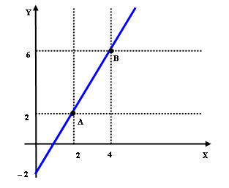

b. There are several ways of getting the equation.
The simplest one is as follows. We are looking for the equation of a line which always have the following form: Y = m * X + b where m is the slope of the straight line and b is the y-intercept of the straight line. To write the equation we need to find the values for m and b. Since both the points A and B are on the line, then:
2 = m * 2 + b
6 = m * 4 + b
Consider the first equation. Then:
2 – 2m = b
Plug that value of b into the second equation:
6 = 4m + (2 – 2m )
Then:
6 = 4m + 2 – 2m
6 = 2m + 2
6 – 2 = 2m + 2 – 2
4 = 2m
Finally:
m = 2
Then:
2 – 2 * 2 = b
2 – 4 = b
b = –2
In this way, the equation of the line is given by:
Y = 2X – 2
This is just one possible way of solving it. If you are used to another one, that’s fine.
The slope is the value we called m before. Thus, the slope is 2.
The Y intercept is the value we called m before. Thus, the Y intercept is –2.
The X intercept can be obtained by asking: For which value of X it is true that the value of Y is 0? We can express that question as follows:
0 = 2X – 2
2 = 2X
1 = X
X = 1
The X intercept is 1.

c.
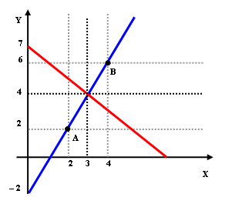

d. We have the following equations:
Y = 2X – 2
Y = 7 – X
The intersection will be given by:
Y = Y
2X – 2 = 7 – X
2X – 2 + 2 = 7 – X + 2
2X = 9 – X
2X + X = 9 – X + X
3X = 9
3/3 X = 9/3
X = 3
We can obtain now the value of Y in the first equation or in the second one. We’ll try with the first one:
Y = 2*3 – 2
Y = 6 – 2
Y = 4
We can check now with the second one:
Y = 7 – 3
Y = 4
Then, the intersection is found at the point ( 3 , 4 )

- Production Possibility Frontier and Opportunity Cost

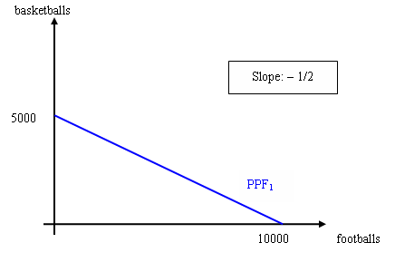
The factory can produce 500(workers)*20(# of footballs produced by each worker per day) =10000 footballs and 500(workers)*10(# of basketballs produced by each worker per day)=5000 basketballs.
Slope=(5000-0)/(0-10000)=-1/2
- In the graph we can see that the y-intercept of the PPF is 5000. So the equation of the PPF is Y= - (½) X + 5000
- 2 footballs. To produce 5000 basketballs, the factory needs to sacrifice 10000 footballs, so the opportunity cost of producing ONE basketball is 10000/5000=2 footballs.
- 1/2 basketballs. To produce 10000 foottballs, the factory needs to sacrifice 5000 basketballs, so the opportunity cost of producing ONE football is 5000/10000=1/2 basketball.
- The opportunity cost of 1 football is the same as the absolute value of the slope of the PPF or 1/2 basketball. The absolute value of the slope of the PPF provides a measure of the opportunity cost of producing one more unit of the good measured on the x-axis.
- A linear PPF has a constant slope, hence constant opportunity cost, while a bowed one has decreasing slope and hence increasing opportunity cost.
- Now the factory can produce 500(workers)*30(# of footballs produced by each worker per day) =15000 footballs per day. The slope of PPF changes to be (5000-0)/(0-15000)=-1/3. So the equation of the PPF is Y= - (1/3) X + 5000
Technological improvements lead to an outward shift of the PPF as
shown in the following graph.

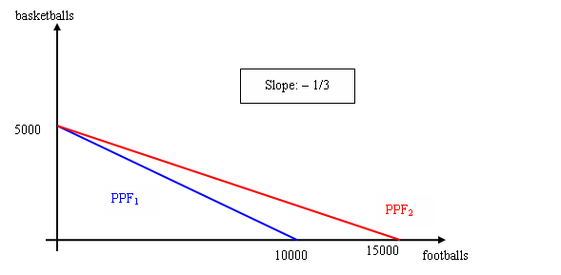

- Comparative Advantage

  - To solve 20 Economics question, Linda has to sacrifice 10 Biology solutions, that is, to solve 1 Economics question, Linda has to sacrifice 10/20=1/2 Biology answers. So the opportunity cost of solving 1 Economics question for Linda is 1/2 Biology solution. For the same reason, we can determine that the opportunity cost of solving 1 Economics question for Jack is 20/30=2/3 Biology answers.
  - The opportunity cost of solving 1 Biology question for Linda is 20/10=2 Economics solutions. The opportunity cost of solving 1 Biology question for Jack is 30/20=3/2 Economics solutions.
  - Jack has the absolute advantage in both Biology and Economics homework.
  - Since Linda has a lower opportunity cost of doing Economics questions than Jack (1/2<2/3), if they work together, Linda will specialize in Economics answers and Jack will specialize in Biology answers.
  - Jack will trade Biology answers for Linda’s Economics answers. The opportunity cost of solving 1 Biology question is 3/2 Economics solutions for Jack. Jack will charge at least 3/2 Economics solutions for every Biology solution. The opportunity cost of solving 1 Biology question is 2 Economics questions for Linda. Linda is at most willing to pay 2 Economics solutions for each Biology solution. Thus the price of 1 Biology answer is between 3/2 and 2 Economics answers.

