Economics 101
Fall 2010
Answers to Homework #1
Due 9/21/2010 at the beginning of lecture

Directions:
The homework will be collected in a box before the lecture.
Place your name, TA name and section number on top of the homework (legibly).
Late homework will not be accepted.
It is essential that you do the homework; you can work with others but you must write up the solutions yourself. Please show your work.
We can’t stop you from using a calculator on your homework, but you will not be able to use them during exams, so we strongly recommend that you do all math by hand.

Math Review:

1.) You’ve got two lines: y=2x+1 and y=2–x
a.) What is the slope of each line?
b.) What is the y-intercept of each line?
c.) What is the x-intercept of each line?
d.) Where do these lines intersect? (Note that you’ll need to be able to do this both graphically and algebraically, but pick your favorite method here.)
e.) Graph these lines neatly.
f.) What would be the equation for a line that is identical to y=2x+1 except that this new line is shifted to the left by five units at every point?

2.) Yi (pronounced “ee”) has got this thing that’s a weird shape and she wants to know its area. Find it! On the y-axis, the units are dollars per cabbage, and on the x-axis the units are number of cabbages. What units should the answer be in? Note that it’s not even a little bit drawn to scale. Hint: If you have trouble with the bottom, right triangle, Google the Pythagorean Theorem!
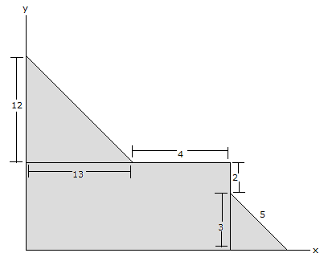

The Production Possibilities Frontier:

3.) This is a story about two peaceful countries. Each one has a population that produces food and makes intercontinental thermonuclear ballistic missiles. They can do these activities in any amount they choose, but each country should be sure that its people get enough to eat (otherwise there is a revolution and the people overthrow the government). The trade-off between food and intercontinental thermonuclear ballistic missiles may be illustrated as follows (for convenience, say y=food and x=nuclear weapons):

USA has a PPF defined by y=100–½x and needs at least y=20 to feed its population
USSR has a PPF defined by y=500–2x and needs at least y=200 to feed its population

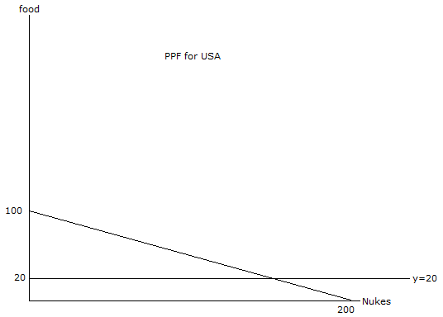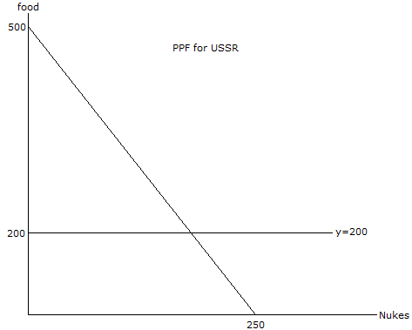
a.) What is the opportunity cost of the USA making one more nuke?
b.) What is the opportunity cost of the USSR making one more nuke?
c.) If these countries are friends and decide to trade, which country will produce only food and which will produce only nukes? Hint: compare opportunity costs to look for a comparative advantage.
Uh oh! It looks like war! These two countries have stopped trading, so now each is forced to produce food and nukes independently. This is a cold war, so the country with the most nuclear weapons automatically wins.
d.) Who is going to win the war, and, more importantly, why? State your answer briefly and justify it with a little algebra.

Opportunity Cost:

4.) Jing (pronounced “jing”) has decided to purchase her textbooks for the semester. Her options are to purchase the books via the Internet with next day delivery to her home at a cost of $175, or to drive to campus tomorrow to buy the books at the university bookstore at a cost of $170. Last week she drove to campus to buy a concert ticket because they offered 25 percent off the regular price of $16.
If Jing is rational what will she do? Explain briefly.

Comparative Advantage and Trade

5.) Suppose Zichen (pronounced “zuh-chin”) and Zhewen (pronounced “jo-win”) are doing Math and Econ homework. Regardless of the difficulty of the problems, it takes 10 minutes for Zichen and 15 minutes for Zhewen to solve one Math question. While solving an Econ question takes Zichen 6 minutes but Zhewen 20 minutes.
a.) In one hour, how many Math questions can Zichen solve? How about Zhewen?
b.) In one hour, how many Econ questions can Zichen solve? How about Zhewen?
c.) Who has the absolute advantage in solving Math questions?
d.) Who has the absolute advantage in solving Econ questions?
e.) What is the opportunity cost of solving a Math question for Zichen? What about for Zhewen?
f.) What is the opportunity cost of solving an Econ question for Zichen? What about for Zhewen?
g.) Who has the comparative advantage in solving Math questions?
h.) Who has the comparative advantage in solving Econ questions?
i.) Suppose they work together. Who will specialize in Math questions and who will specialize in Econ questions? (TA’s note to students: don’t try this at home; it’s academically unethical!)
j.) If they were to trade with each other, what is the price range (in terms of number of Math problems) acceptable to both Zichen and Zhewen for an Econ question?

6.) Consider Robinson Crusoe, the famous novel by Daniel Defoe (we adapt it a little for our purpose). Suppose Friday stayed on the island of Despair when Robinson was rescued. As the only person on the island, Friday produces only two kinds of food: coconuts and fish. In one week, Friday can produce 100 coconuts and 0 fish, or 0 coconuts and 50 fish, or any other combination lying on the line between these two points. Meanwhile, Robinson comes and visits Friday every week during his journey of selling coconuts and fish all over the world. Suppose Robinson is willing to pay $2 per coconut and $1 per fish when he buys coconuts or fish.
a .) What is the opportunity cost of producing a coconut for Friday?
b .) Robinson is interested in getting coconuts from Friday. What is the maximum number of fish Robinson is willing to pay for one coconut?
c .) Is Friday willing to trade with Robinson according to the above prices ($2 per coconut and $1 per fish)? (Hint: you might find it handy to consider the ratio $2 per coconut/$1 per fish and then simplify the units of measurement in this ratio to see Robinson’s opportunity cost of producing 1 coconut.)
d .) If Friday wants to trade with Robinson, what will Friday sell and what will he buy? If Friday does not want to trade, explain why?

Solutions to HW#1
1.)
a.) What is the slope of each line? 2 and -1
b.) What is the y-intercept of each line? 1 and 2
c.) What is the x-intercept of each line? -1/2 and 2
d,) Where do these lines intersect? (1/3, 5/3)
e.) Graph these lines neatly. Make sure their answer is neat!
f.) What would be the equation for a line that is identical to y=2x+1 except that this new line is shifted to the left by five units at every point? y=2(x+5)+1 → y=2x+11

2.) The whole shaded area is 169 dollars.
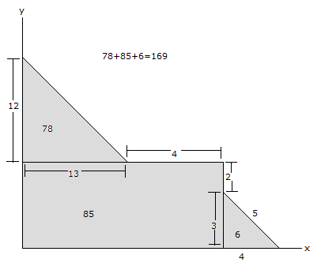
3.)
a.) What is the opportunity cost of the USA making one more nuke? .5 food
b.) What is the opportunity cost of the USSR making one more nuke? 2 food
c.) If these countries are friends and decide to trade, which country will produce only food and which will produce only nukes? USA would make nukes and USSR would make food
d.) Who is going to win the war, and, more importantly, why? State your answer briefly and justify it with a little algebra. The USA wins the war, because at minimum food levels for each country, the US has 160 nukes and the USSR has 150.

4.) If Jing is rational what will she do? Explain briefly.
Jing will drive to campus again for the books to save $5 because she already went to campus to save $4 on the concert ticket.

5.)
a.) In one hour, how many Math questions can Zichen solve? How about Zhewen? Zichen: 60 minutes/10 (minutes per Math question) = 6 Math questions; Zhewen: 60 minutes/15 (minutes per Math question) = 4 Math questions
b.) In one hour, how many Econ questions can Zichen solve? How about Zhewen? Zichen: 60 minutes/6 (minutes per Econ question) = 10 Econ questions; Zhewen: 60 minutes/20 (minutes per Econ question) = 3 Econ questions
c.) Who has the absolute advantage in solving Math questions? Zichen, he can solve more Math questions per hour than Zhewen.
d.) Who has the absolute advantage in solving Econ questions? Zichen, he can solve more Math questions per hour than Zhewen.
e.) What is the opportunity cost of solving a Math question for Zichen? What about for Zhewen? Zichen: 5/3 Econ questions. In order to solve one Math question, he has to spend 10 minutes. If he use this amount of time to solve Econ questions, he can solve 10 minutes/ 6 (minutes per Econ question) = 5/3 Econ questions. Zhewen: 3/4 Econ questions. In order to solve one Math question, he has to spend 15 minutes. If he use this amount of time to solve Econ questions, he can solve 15 minutes/ 20 (minutes per Econ question) = 3/4 Econ questions.
f.) What is the opportunity cost of solving an Econ question for Zichen? What about for Zhewen? Zichen: 3/5 Math questions. In order to solve one Econ question, he has to spend 6 minutes. If he use this amount of time to solve Math questions, he can solve 6 minutes/ 10 (minutes per Math question) = 3/5 Math questions. Zhewen: 4/3 Math questions. In order to solve one Econ question, he has to spend 20 minutes. If he use this amount of time to solve Math questions, he can solve 20 minutes/ 15 (minutes per Math question) = 4/3 Econ questions.
g.) Who has the comparative advantage in solving Math questions? Zhewen. His opportunity cost of solving one Math question is smaller than that of Zichen’s.
h.) Who has the comparative advantage in solving Econ questions? Zichen. His opportunity cost of solving one Econ question is smaller than that of Zhewen’s.
i.) Suppose they work together. Who will specialize in Math questions and who will specialize in Econ questions? Zhewen will specialize in Math questions and Zichen will specialize in Econ questions.
j.) If they were to trade with each other, what is the price range (in terms of number of Math problems) acceptable to both Zichen and Zhewen for an Econ question? 3/5-4/3 Math questions
Zhewen is the buyer of Econ questions. The highest price he would pay for an Econ question is 4/3 Math questions, his opportunity cost of solving an Econ question. If the price of an Econ question is higher than this, he would choose to do it himself. So 4/3 Math questions is the highest price of an Econ question for a potential trade. Zichen is the seller of Econ questions. The lowest price he would ask for an Econ question is 3/5 Math questions, his opportunity cost of solving an Econ question. If the price of an Econ question is lower than this, he will make a negative profit by selling Econ questions. So 3/5 Math questions is the lowest price of an Econ question for a potential trade.

6.)
a .) What is the opportunity cost of producing a coconut for Friday? 0.5 fish. In order to produce 100 coconuts, Friday has to give up 50 fish. So the opportunity cost of 100 coconuts is 50 fish. The opportunity cost of 1 coconut is thus 50 fish/100=0.5 fish.
b .) Robinson is interested in getting coconuts from Friday. What is the maximum number of fish Robinson is willing to pay for one coconut? 2 fish; a coconut is worth $2 for Robinson. Because the unit price of fish is $1, he would want to pay $2/$1 per fish = 2 fish for a coconut
c .) Is Friday willing to trade with Robinson according to the above prices ($2 per coconut and $1 per fish)? Yes. By giving up one coconut, Friday can get two fish according to the above prices, t. Without this trade opportunity, he can get only 0.5.
d .) If Friday wants to trade with Robinson, what will Friday sell and what will he buy? If Friday does not want to trade, explain why? He will sell coconuts and buy fish. Because his opportunity cost of producing coconuts (0.5 fish) is lower than that of Robinson’s (2 fish)

