Economics 101

Homework #1

Fall 2009

Answer Key

- Math Review

Suppose that you have two straight lines, Line A and Line B. The points (x, y) = (2, 6) and (4, 2) lie on Line A. The points (x, y) = (1, 9) and (3, 3) lie on Line B.

  - Write the equations of Line A and Line B in slope-intercept form.
Line A: slope = (6 - 2)/(2 - 4) = -2.
Set the equation y = -2x + b. 6 = -2(2) + b → b = 6 + 4 = 10

Answer: y = -2x + 10
Line B: slope = (9 - 3)/(1 - 3) = -3. y = -3x + b. 9 = -3 + b → b = 9 + 3 = 12
Answer: y = -3x + 12

  - Indicate the slope for each line.
Line A: y = -2x + 10 Line B: y = -3x + 12
Answer: slope of Line A = -2; slope of Line B = -3

  - Indicate the X and Y intercepts of the straight lines.
Line A: y = -2x + 10 Line B: y = -3x + 12
Answer: y-intercept of Line A = 10; x- intercept of Line A = 5. Y-intercept of Line B = 12; x-intercept of Line B = 4.

  - What is the point of intersection between Line A and Line B?
Set the two equations equal to one another: -2x + 10 = -3x + 12 → x = 2.
Plug x = 2 into the equation for line A( or B): y = -2*2 + 10 = 6. Thus, y = 6

Answer: (x, y) = (2, 6)

  - Graph Line A and Line B.
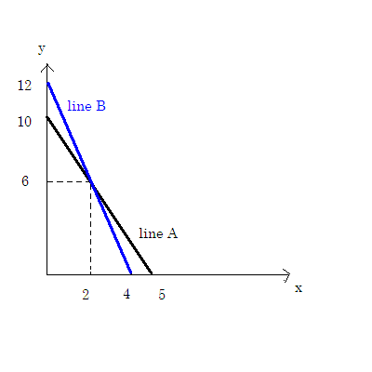

  - Suppose you are given an equation for the line y = 2x + 5. Furthermore, suppose you are told to write a new equation which corresponds to this first equation moving to the right horizontally by 3 units. What is the equation for this new line?
y=2(x - 3) + 5 = 2x - 1

Answer: y = 2x - 1

- Production Possibility Frontier and Opportunity Cost

Bohemia is a community that produces two goods, ground beef and milk. The following table describes the production possibility frontier (PPF) for Bohemia during 2009. Assume the PPF is linear between the points listed in the table.

Points on PPF | Milk (Gallons) | Ground beef (Pounds)
A | 0 | 100
B | 10 | 90
C | 40 | 0

  - Draw a graph of Bohemia’s PPF for 2009 based on the information contained in the table. In your graph, measure ground beef (G) on the vertical axis and milk (M) on the horizontal axis.

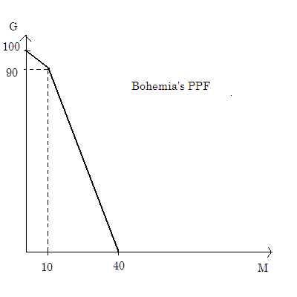
C
A
B

  - Suppose Bohemia is currently producing at point B on their PPF. What is the opportunity cost of producing one additional gallon of milk?

To produce one more gallon of milk, Bohemia has to give up producing
(90 - 0)/(40 - 10) = 90/30 = 3 pounds of ground beef. Thus, the opportunity cost of 1 gallon of milk at point B is 3 pounds of ground beef.

  - Suppose Bohemia is still producing at point B on their PPF. What is the opportunity cost of producing one additional pound of ground beef?

To produce one more pound of ground beef, Bohemia has to give up producing
(10 - 0)/(100 - 90) = 10/10 = 1 gallon of milk. Thus, the opportunity cost of 1 pound of ground beef at point B is 1 pound of milk.

  - If Bohemia is currently producing at combination A, what is the opportunity cost of producing 10 more gallons of milk?

To produce 10 more gallons of milk, Bohemia has to give up producing 100 - 90 = 10 pound of ground beef. Thus, the opportunity cost of 10 gallons of milk at point B is 10 pounds of ground beef.

  - What is happening to the opportunity cost of producing more milk if we move from point A to point C? Explain your answer.

The opportunity cost of producing more milk increases as we move from A to C since some of the resources in this economy are more suited to the production of one of the goods than the production of the other good.

- Comparative Advantage and Trade

Suppose Edith and Mary have two kinds of household chores to do every day: washing dishes and preparing meals (nothing else). Regardless of the number of dishes, it takes 1 minute for Edith and 30 minutes for Mary to wash a dish. Preparing a meal takes Edith 20 minutes but Mary 30 minutes.

  - In one hour, how many dishes can Edith wash? How about Mary?

Edith: 60 (minutes) /1(minute / dish) = 60 dishes
Mary: 60 (minutes) /30(minute / dish) = 2 dishes

  - In one hour, how many meals can Edith prepare? How about Mary?
Edith: 60 (minutes) /20(minute / meal) = 3 meals
Mary: 60 (minutes) /30(minute / meal) = 2 meals

  - Who has the absolute advantage in washing dishes?
Answer: Edith
She can wash more dishes per hour.

  - Who has the absolute advantage in preparing meals?
Answer: Edith
She can prepare more meals per hour.

  - What is the opportunity cost of washing a dish for Edith? What about for Mary?

Edith: 1/20 meal. To wash a dish, Edith has to give up preparing 3/60 = 1/20 meal.
Mary: 1 meal. To wash a dish, Mary has to give up preparing 30/30 = 1 meal.

  - What is the opportunity cost of fixing a meal for Edith? What about for Mary?
Edith: 20 dishes To prepare a meal, Edith has to give up preparing 60/3 = 20 dishes.
Mary: 1 dish. To prepare a meal, Mary has to give up preparing 30/30 = 1 dish.

  - Who has the comparative advantage in washing dishes?
Edith. She has a lower opportunity cost of washing a dish than Mary.

  - Who has the comparative advantage in preparing meals?
Mary. She has a lower opportunity cost of preparing a meal than Edith.

  - Suppose they share the house chores. Who will specialize in dish washing and who will specialize in cooking?
Edith will specialize in washing dishes and Mary in preparing meals.

  - Suppose you are an economist who supports the theory of comparative advantage. Your friend Edith asks your advice in the following situation.

Situation: Edith only has 1 hour to do the house chores each day, but wants to have 3 meals and wants 10 dishes to be washed. She cannot afford to hire a housekeeper or to dine out. She has two roommates Judy and Mary and it is possible she could share the work with them. None of them will provide Edith with free service, but they are willing to exchange the work and service with one another. Furthermore, assume that they all will be happier the greater their consumption levels (e.g, a greater number of washed dishes with the same amount of meals is better than a smaller number of washed dishes with the same level of meals).

The productivity for the house chores are described as follows:

 | Edith | Judy | Mary
Prepare a meal | 20 minutes | 20 minutes | 30 minutes
Wash a dish | 1 minute | 1 minute | 30 minutes

Assume everybody has 1 hour available each day to devote to these household tasks.
Can Edith have 3 meals and 10 clean dishes every day? Pick your answer from options I) - III) and then explain briefly why you have chosen that answer.

I) It is possible if she shares the work with Mary.
II) It is possible if she shares the work with Judy.
III) There is no way for Edith to achieve her goal.

Answer I). First, notice that Edith and Judy have the same opportunity cost for each task and neither of them has a comparative advantage in the household production of either washed dishes or prepared meals (their opportunity costs for producing either good are the same). Compared with Mary, Edith has a lower opportunity cost in washing dishes while Mary has a lower opportunity cost in preparing meals. By choosing to share household tasks with Mary and then trading with one another, it is possible for Edith to be better off than she would be if she did not specialize and trade.

Indeed, Edith could consume 3 meals and have 10 clean dishes if she produces 2 meals and 20 clean dishes and then exchanges 10 clean dishes with 1 meal prepared by Mary. Mary would accept this trade since washing 10 dishes takes her 300 minutes while preparing 1 meal takes her only 30 minutes. If such a trade occurs, it will benefit Edith since it enables her to consume 3 meals and 10 clean dishes, a point that lies beyond her own PPF.

- Comparative Advantage and Trade

Suppose Ann and Drew are doing Biology and Math homework. In one hour, Ann can solve 10 Biology questions or 20 Math questions, or any other combination lying on the straight line between those two points. In the same amount of time, Drew can solve 4 Biology questions or 16 Math questions, or any other combination lying on the straight line between those two points.

If they were to trade with each other, what is the price range (in terms of number of Math problems) acceptable to both Ann and Drew for a Biology question?

Answer: The price of 1 Biology answer is between 2 and 4 Math answers.

Each person will produce the good for which they have the comparative advantage.
Ann will specialize in solving biology questions since that is her comparative advantage.
It costs Ann 2 math questions to solve a bio question so she won’t trade for anything less than 2 math questions. Drew could solve bio questions himself at a cost of 4 math questions so he won’t pay any more than that.
Therefore the price won’t be less than 2 math questions and it won’t be higher than 4 math questions.

Price of one Bio question
2 math questions
4 math questions
Ann (Seller)
Drew (Buyer)
Trade price range
No trade
No trade

