Econ 101 – Summer 2012 Exam 1 – Professor Kelly

Name: ___________________________________
Section Day and Time: ____________________________

On this exam it is important that you show your work to get FULL CREDIT.
On this exam you should write any verbal answer using standard English grammar: that is, please write in complete sentences.
The exam consists of 20 multiple choice questions worth 2.5 points for a total of 50 points, and three problems worth a total of 50 points.
Multiple Choice Score Your Score: ______________
Question 1 – 20 points Your Score: ______________
Question 2 – 15 points Your Score: ______________
Question 3 – 15 points Your Score: ______________
Total: 100 points Your Total: _______________

No calculators are allowed for the exam. Cell phones should be silenced and in your backpacks, away from your seat.
You will have 75 minutes to work. Good luck.

I, __________________________________, agree to neither give nor receive any help on this exam from other students. Furthermore, I understand that use of a calculator is an academic misconduct violation on this exam.
Signed ____________________________________

1. (20 points total) Eeyore and Rabbit live in the Hundred Acre Wood. Both can spend their time planting vegetables or looking for sticks. The following graph shows their linear production possibilities. You are also told that the opportunity cost of producing one unit of vegetables for Rabbit is 1/3 unit of sticks found and that the opportunity cost of producing one unit of vegetables for Eeyore is ¼ unit of sticks found.
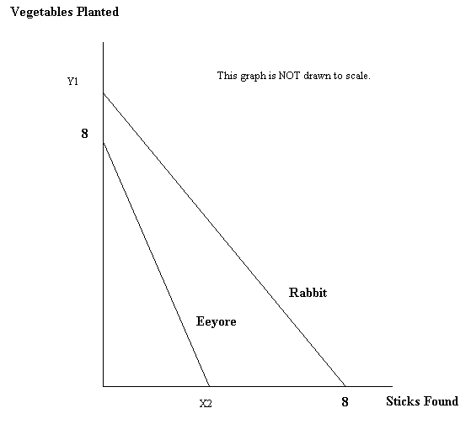
- (1 point) What is the value of Y1? In your answer provide the units of measurement. _______24 vegetables planted_______________

- (1 point) What is the value of X2? In your answer provide the units of measurement. _______2 sticks found______________

- (2 points) Who has the comparative advantage in planting vegetables? Eeyore__________

- (2 points) Who has the comparative advantage in finding sticks? Rabbit ______________

- (2 points) What is Eeyore’s opportunity cost for finding a stick? Provide the units of measurement in your answer. 4 units of a vegetable________

- (2 points) What is Rabbit’s opportunity cost for planting TWO vegetables? Provide the units of measurement in your answer. 2/3 of a stick_____

- (2 points) Draw a graph in the space below illustrating the joint production possibility frontier for Eeyore and Rabbit. Make sure that all axes are labeled, all intercepts are labeled with numeric values and any “kink” points on your graph are labeled with numeric values.

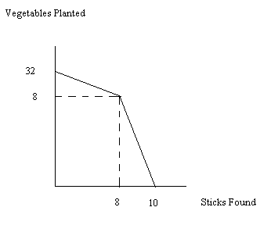

- (4 points) Suppose that Rabbit and Eeyore decide to specialize according to their comparative advantages and then trade. What is the range of amounts of vegetables that both would agree to trade in exchange for twenty sticks?
From 60______ vegetables up to 80_____ vegetables for twenty sticks.

- (2 points) Suppose that Rabbit discovers new technology that allows him to double his production of sticks but does not affect his ability to grow vegetables. In the space below draw Rabbit’s new PPF making sure to label all axes and intercepts.

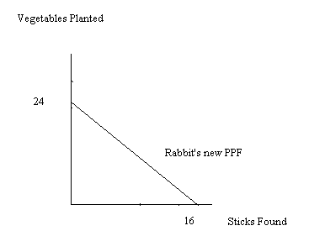

j) (2 points) Given the change described in part (i), who has the comparative advantage in the production of vegetables holding everything else constant?
Eeyore still has the comparative advantage in the production of vegetables.
2. (15 points in all) The diagram below represents Sam’s production possibility frontier for producing hats (H) and belts (B). Assume this production possibility frontier is linear between each marked point (e.g., the PPF is linear between points A and B, linear between points B and C, etc.). Use this graph to answer the following set of questions.
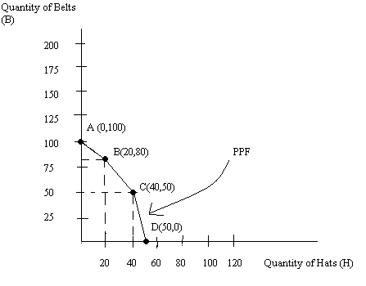
a. (2 points) Suppose Sam is currently producing at point B. What is Sam’s opportunity cost of producing two additional belts? Provide a number as well as the units of measurement in your answer.
Answer:
The equation for the PPF between points A and B is B = 100 – H. If Sam produces 82 belts this implies that he can produce 18 hats. The opportunity cost of producing these two additional belts is 2 hats.
b. (2 points) Provide an equation in slope intercept form for Sam’s production possibility frontier between points B and C. In your equation use H as the symbol for hats and B as the symbol for belts.
Answer:
Y = mX + b
B = (-3/2)H + b
50 = (-3/2)(40) + b
110 = b
B = 110 – (3/2)(H)
c. (2 points) Suppose Sam is currently producing 30 hats. What is the maximum number of belts he can produce given this level of hat production?
Answer:
The equation for the PPF between points B and C is B = 110 – (3/2)H. If H = 30 then B = 110 – (3/2)(30) = 110 – 45 = 65 belts.
d. (2 points) Suppose Sam is currently producing at point C. What is the opportunity cost of producing an additional 5 hats?
Answer:
The equation for the PPF between points C and D is B = 250 – 5H. At C Sam is producing 40 hats and 50 belts. If he produces 45 hats (5 additional hats) he can only produce B = 250 – 5(45) = 25 belts. The opportunity cost of producing 5 additional hats is 25 belts.
e. (4 points) Suppose technology changes so that Sam is able to produce twice as many hats from his available resources and the given time period than he could initially. In the space below amend the diagram to include Sam’s new PPF. Label with numeric values the endpoints of any linear segment.
Answer:
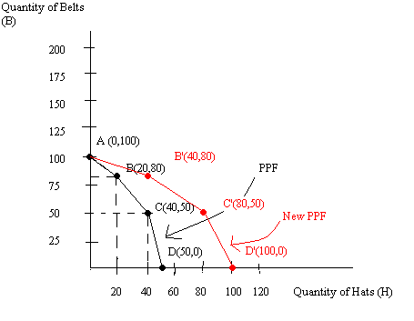

f. (3 points) Given the technology change described in (d), what has happened to Sam’s opportunity cost of producing hats? Provide a factual but generalized statement about the change in opportunity cost.
Answer:
The opportunity cost of producing hats has decreased due to the technological improvement in the production of hats.
3. (15 points) You are told that Millicent purchases 10 oranges when the price of each orange is $0.20. You also know that for every $0.10 increase in price Millicent purchases one less orange. Millicent’s demand curve is linear.
a. (5 points) In the space below draw a sketch of Millicent’s demand curve given the above information. Your sketch should identify two points that lie on this demand curve (give numerical values for the coordinates of these two points). Your sketch should have both axes labeled as well as the demand curve.
Answer:
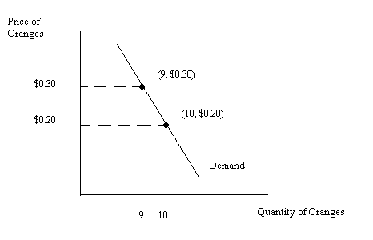
b. (2 points) Given the above information write an equation for Millicent’s demand curve for oranges using P as the symbol for the price per orange and q as the symbol for the quantity of oranges demanded by Millicent. For full credit show your work in deriving this equation.
Answer:
P = b + mq
m = -.1/1 = -0.1
P = b + (-0.1)q
0.2 = b + (-0.1)(10)
b = 1.20
P = 1.20 - .1q or P = 1.20 – (1/10)q or q = 12 – 10P
c. (4 points) Suppose there are twenty individuals in all (including Millicent) in this market and all of these individuals have identical demand curves based on the information you were given about Millicent. Provide a verbal explanation of how you would find the market demand curve.
Answer:
To find the market demand curve you would horizontally sum the amount demanded by these twenty individuals at each price. That is, holding price constant, you would ask what is the total amount of the good demanded at this price? You would repeat this process at different prices and then use these (quantity, price) combinations to write the market demand curve.
d. (4 points) Find this market demand curve using P as the price per orange and Q as the total quantity demanded by these twenty individuals. (Hint: you may find it helpful to draw a sketch of Millicent’s demand curve and a separate sketch of the market demand curve.) Show your work to get full credit.
Answer:
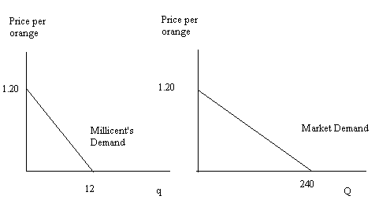
Millicent’s demand curve: P = 1.20 – (1/10)q or q = 12 – 10P
Market Demand curve: P = 1.20 – (1.20/240)Q
P = 1.20 - .005Q or Q = 240 – 200P

Multiple Choice Questions (20 questions worth 2.5 points each):
1. Jason read in the newspaper this morning that gas prices are rising due to increases in car ownership in China. Which of the following graphs is the best illustration of this idea? (S1 refers to the initial supply curve and D1 refers to the initial demand curve.)

a.
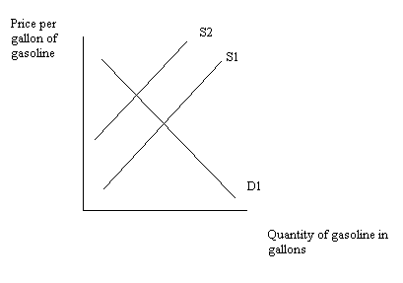
b.
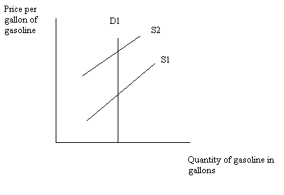
c.
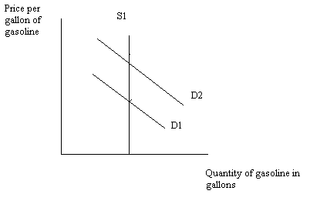
d.
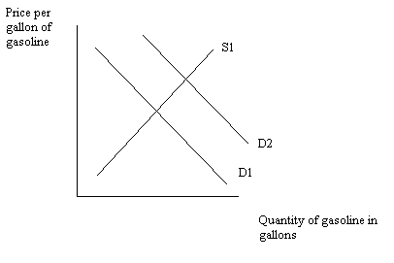

Use the following information to answer the next four (4) questions.
Suppose Sarah and Carolyn both have 100 hours available to use in producing belts and hats. The table below tells us the number of hours needed to produce 1 belt or 1 hat for Sarah and Carolyn.
 | Hours of Labor to Produce One Hat | Hours of Labor to Produce One Belt
Sarah | 2 | 4
Carolyn | 4 | 10

2. Given the above information, the maximum number of belts that can be produced by Sarah and Carolyn is
a. 14 belts
b. 25 belts
c. 10 belts
d. 35 belts

3. Suppose both Carolyn and Sarah are producing on their production possibility frontiers. Carolyn is producing 15 hats while Sarah is producing 20 belts. The total number of hats being produced given this information is
a. 15 hats
b. 25 hats
c. 24 hats
d. 35 hats

4. Given the above information the acceptable trading range of prices for 5 belts is between
a. 2 and 2.5 hats
b. 2.5 and 12. 5 hats
c. 10 and 12.5 hats
d. 2 and 10 hats

5. If Carolyn and Sarah specialize completely according to their comparative advantage their joint production possibility frontier will be (Note: that these graphs are not drawn to scale!)

a.

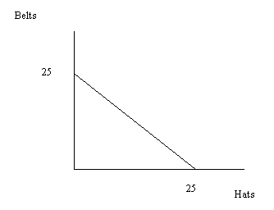

b.

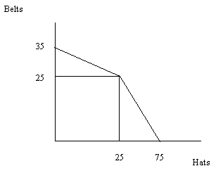

c.

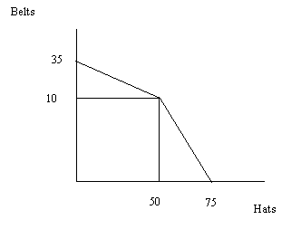

d.
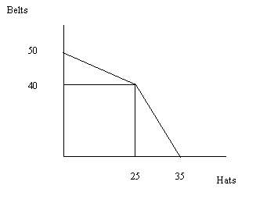

6. Consider the market for bicycles which is initially in equilibrium. Suppose that the number of bicycle producers increases at the same time that the cost of labor decreases. Which of the following statements is true about the market for bicycles given this information?

a. The equilibrium price will decrease and the equilibrium quantity will increase.
b. The equilibrium price will increase and the equilibrium quantity will decrease.
c. The equilibrium price may increase, decrease or remain the same while the equilibrium quantity will increase.
d. The equilibrium quantity may increase, decrease or remain the same while the equilibrium price will decrease.

7. Challenge Question (this question is not hard, it just asks you to read carefully and to THINK.) Joe’s income elasticity of demand for oranges has a negative value. (Hint: Income elasticity of demand is the percentage change in the quantity demanded divided by the percentage change in income.) From this information we can conclude that

a. When Joe’s income increases Joe will consume more oranges.
b. When Joe’s income increases Joe will consume fewer oranges.
c. When Joe’s income increases, his demand curve for oranges shifts to the right.
d. When the price of grapefruits increases, Joe will consume more oranges.

8. Consider the market for calculators. Initially the market is described by the following two equations where P is the price per calculator and Q is the quantity of calculators:
Market Demand: P = 200 – Q
Market Supply: P = 50 + (1/2)Q
Suppose you are told that three new producers enter this market. The supply curve for each of these new producers is given by the equation:
Individual Firm Supply Curve: P = 50 + (1/4)Q
The new market supply curve is

a. P = 100 + (3/4)Q
b. P = 50 + (3/4)Q
c. P = 50 + (1/12)Q
d. P = 50 + (1/14)Q

9. Consider the market for gasoline that is initially in equilibrium. Suppose that the Middle East, a major supplier of petroleum used to produce gasoline, erupts into a widespread war. At the same time suppose that the price of electric vehicles falls. Given these changes and holding everything else constant, what happens to the equilibrium price and quantity in the market for gasoline relative to the initial equilibrium price and quantity in the market?
a. The equilibrium price may increase, decrease or remain the same while the equilibrium quantity will decrease.
b. The equilibrium price may increase, decrease or remain the same while the equilibrium quantity will increase.
c. The equilibrium price will increase while the equilibrium quantity may increase, decrease or remain the same.
d. The equilibrium price will decrease while the equilibrium quantity may increase, decrease or remain the same.

10. Consider the market for bananas in a small closed economy. If this economy decides to open to trade, which of the following statements will be true?
I. If the world price of bananas is always greater than the domestic price of bananas, this small economy will not benefit from opening this market to trade.
II. It will only be beneficial to this country to open to trade if the world price of bananas is less than the domestic price of bananas.
III. Provided that the world price of bananas is not equal to the domestic price of bananas, opening this economy to trade will increase total surplus but it may decrease consumer surplus.
a. Statement I is correct.
b. Statement II is correct.
c. Statement III is correct.
d. Statements I and II are correct.
e. Statements I and III are correct.

Use the following information to answer the next three questions.

Johnsonville is a small closed economy that produces widgets. Suppose that the domestic demand and domestic supply curves for widgets are given by the equations below where P is the price per widget and Q is the number of widgets.
Domestic Demand: P = 500 – 5Q
Domestic Supply : P = 100 + 5Q
Furthermore, you are told that the world price of widgets is $200.

11. Given the above information and holding everything else constant, what is the value of total surplus when this economy opens to trade?

a. $10,000
b. $20,000
c. $9000
d. $1000

12. Suppose this small economy opens to trade while simultaneously imposing an import quota of 50 widgets. Which of the following statements is true given this information?

a. The price of widgets will be $175 in Johnsonville.
b. The price of widgets in Johnsonville given this quota must be higher than the world price of widgets.
c. 40 widgets will be imported and the price of widgets in Johnsonville will be $200.
d. 50 widgets will be imported and the price of widgets in Johnsonville will be greater than $200.

13. Suppose Johnsonville imposes a tariff on the market for widgets (assume there is no quota in place) at the same time that it opens this market to trade. If the tariff is $20 per widget then

a. The deadweight loss is equal to $80, tariff revenue is equal to $640, and producer surplus in the small economy equals $1440.
b. The deadweight loss is equal to $40, tariff revenue is equal to $7040, and producer surplus in the small economy equals $720.
c. This policy will hurt domestic consumers relative to the outcome when the market is simply opened to trade.
d. This policy will hurt domestic producers relative to the outcome when the market is simply opened to trade.
e. Answers (a) and (c) are both true.
f. Answers (a) and (d) are both true.
g. Answers (b) and (c) are both true.

14. Consider the market for soybeans. Suppose that the equilibrium price in the market is $50 per ton and that the equilibrium quantity in the market is 100 tons. Furthermore, suppose that both the demand and supply curves are linear, the positively slope supply curve has a y-intercept of 0, and the y-intercept of the demand curve is greater than $100. If the government imposes an effective price floor of $75 then

a. Producer surplus must increase, consumer surplus must decrease, and this policy will result in a deadweight loss to the economy.
b. Producer surplus must decrease, consumer surplus must decrease, and this policy will result in a deadweight loss to the economy.
c. Producer surplus must increase, consumer surplus must increase, and this policy will result in a deadweight loss to the economy.
d. We cannot be certain what happens to consumer or producer surplus relative to their initial levels, but we know this policy will result in a deadweight loss to the economy.

Use the information below about the market for corn to answer the next three questions.

The market for corn is described by the graph below where P is the price of corn, Q is the quantity of corn, S is the supply of corn, and D is the demand for corn. Use this graph to answer this set of questions. Assume this graph is drawn to scale.
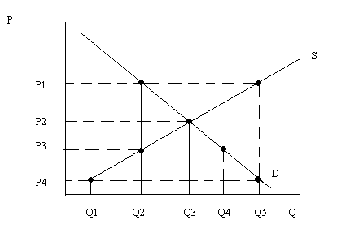
15. Suppose that the government promises farmers to pay them a total price of P1 per ton of soybeans but the government instructs the farmers in this market to sell as much of the soybeans as they can. Then, the government will pay a subsidy to the farmers equal to the difference between the price the government guaranteed and the price the soybeans actually sold for in the market. Given this program we know that the cost to the government

a. Is equal to P1(Q5 – Q2) and the total revenue received by farmers is equal to P1(Q5).
b. Is equal to (P1 – P4)(Q5) and the total revenue received by farmers is equal to (P1 – P4)(Q5).
c. Is equal to (P1 – P4)(Q5) and the total revenue received by farmers is equal to P1(Q5).
d. Is equal to (P1)(Q5 – Q2) and the total revenue received by farmers is equal to (P1 – P4)(Q5).

16. Suppose that in the market depicted in the graph the government implements an effective price ceiling of P3. Which of the following statements is true?

a. Consumer surplus is now larger than it was initially.
b. Producer surplus is now larger than it was initially.
c. Q4 units of corn will be sold in the market given this price ceiling.
d. Q3 units of corn will be sold in the market given this price ceiling.

17. Assume for this question that the market depicted in the above graph is drawn to scale. Furthermore assume there are no storage costs for any imposed government program. Suppose the government wishes to stabilize the price of corn to the level depicted as P1 in the graph. Given this information and holding everything else constant, which of the following statements is true?

a. The cost to the government of using a subsidy program to reach this goal is greater than the cost to the government of using a price floor to reach this goal.
b. The cost to the government of using a subsidy program to reach this goal is less than the cost to the government of using a price floor to reach this goal.
c. The cost to the government of using a subsidy program to reach this goal is equal to the cost to the government of using a price floor to reach this goal.
d. There is not enough information in the graph to definitively answer this question.

Use the information below to answer the next three questions.

Consider the market for flashlights. The demand and supply curves for flashlights are given below where P is the price per flashlight and Q is the quantity of flashlights.
Demand: P = 50 – 5Q
Supply: P = 10 + (5/3)Q

18. When this market is in equilibrium, consumer surplus equals ___________, producer surplus is equal to _____________, and the area of deadweight loss is equal to __________.

a. $90, $60, $0
b. $90, $30, $0
c. $180, $30, $0
d. $180, $60, $0

19. Suppose the government implements an excise tax of $5 per flashlights on the producers of flashlights. We know that this will

a. Increase the price of flashlights to consumers and reduce the quantity of flashlights sold.
b. Reduce consumer surplus and producer surplus while creating a positive deadweight loss.
c. Reduce consumer surplus while increasing producer surplus and generating a positive deadweight loss.
d. Answers (a) and (b) are both correct.
e. answers (a) and (c) are both correct.

20. Suppose the government implements an excise tax of $5 per flashlights on the producers of flashlights. Given this excise tax and holding everything else constant, which of the following statements is true?

a. This excise tax will result in a deadweight loss of $3.75.
b. This excise tax will result in tax revenues equal to $3.75.
c. This excise tax will result in consumer tax incidence equal to ($3.75)(5.25 units of flashlights).
d. This excise tax will result in producer tax incidence equal to ($3.75)(5.25 units of flashlights).

