Economics 101 Name ________________________________
Summer 2009 Day and Time of Discussion Section _______
Answers to First Midterm Student ID Number _____________________
6/3/09
Version 1
DO NOT BEGIN WORKING UNTIL THE INSTRUCTOR TELLS YOU TO DO SO. READ THESE INSTRUCTIONS FIRST.
You have 90 minutes to complete the exam. The exam consists of three parts: Part I is 10 Binary Choice Questions worth 1.5 points each for a total of 15 points; Part II is 18 Multiple Choice Questions worth 2.5 points each for a total of 45 points; and Part III is 3 Problems worth 10 points each for a total of 30 points. The total point value of the exam is 90 points. Parts I and II should be answered on the scantron sheet that we will provide. Please answer all questions on the scantron sheet with a #2 pencil.
No cell phones, calculators, or formula sheets are allowed.
PICK THE BEST ANSWER FOR EACH QUESTION IN PARTS I AND II.
How to fill in the scantron sheet:
- Print your last name, first name, and middle initial in the spaces marked "Last Name," "First Name," and "MI." Fill in the corresponding bubbles below.
- Print your student ID number in the space marked "Identification Number." Fill in the bubbles.
- Write the number of the discussion section you are enrolled in under "Special Codes" spaces ABC, and fill in the bubbles. You can find the discussion numbers below on this page.
- Write the version number of your exam booklet under "Special Codes" space D, and fill in the bubble. The version number is on the top of this page.
- If there is an error on the exam or you do not understand something, make a note on your exam booklet and the issue will be addressed AFTER the examination is complete. No questions regarding the exam can be addressed while the exam is being administered.
- When you are finished, please get up quietly and bring your scantron sheet and this exam booklet to the place indicated by the instructors.

Discussion Section | Time | Day
301 | 4:20-5:35 | Wednesday
302 | 4:20-5:35 | Thursday
303 | 11:30-12:45 | Thursday

Problem | Score on Problem
#1
#2
#3
I. 10 Binary Choice Questions: (Worth 1.5 points each)

1. Joe and Susie are both economists. Susie has constructed an economic model of the economy that she uses to explain the effect of government spending programs on the level of gross domestic product (GDP). Joe has also developed an economic model of the economy that he uses to explain the effect of government spending programs on the inflation rate in the economy. Joe’s model predicts that constant levels of government spending over time will result in high levels of inflation and he concludes therefore that government spending should be avoided as much as possible. Susie’s model predicts that government spending can stimulate the economy and therefore increase employment if there is a crisis of confidence and the economy is in a recession. Susie concludes that government spending is potentially beneficial. The differences in Joe and Susie’s conclusions are primarily due to

a. Normative differences between Joe and Susie.
b. Positive differences between Joe and Susie.

2. Marsha collects data about student performance in the local public education system and is startled to find that in her sample the average grade point average is 3.97 on a 4 point scale. Which of the following statements is likely to be true?

a. Marsha drew her sample of students from the National Honor Society rosters at each of the high schools she surveyed.
b. Marsha randomly selected students from the enrollment rosters at each high school.

3. For a model to be useful it must

a. Represent a realistic image of the item being modeled.
b. Make useful predictions.

4. Indeterminacy in prices happens when

a. Supply and Demand move in the same direction.
b. Supply and Demand move in opposite directions.

For the next question use the information given below about the demand for a good in a small economy.

Domestic Demand: P = 20
Domestic Supply: Q = P - 10
International Price (the world price): P* = 30

5. Suppose the economy described by the equations above is in autarky (that is, the economy is closed to trade). Then

a. Consumer surplus is bigger than under free trade and Q = 10.
b. Producer surplus is $50 and Q = 10.

6. The supply curve for cucumbers is represented by the equation Q = P - 3 . Suppose that cucumber farmers in this market invent a new technology to grow cucumbers, so they can now produce more cucumbers at every price than they could before the invention of this new technology. Holding everything else constant, which of the following equations could represent this change in the supply curve?

a. Q = P - 4
b. Q = P - 2

7. Vivian can spend her time reading her economics textbook or reading her Vogue magazine. In twenty minutes, Vivian can either read 7 pages of her economics text or 10 pages of her Vogue magazine. Today, Vivian has 1 hour to dedicate to reading, and she would like to read 6 pages from her economics textbook and 20 pages from her Vogue Magazine. This combination is ___________.

a. Feasible
b. Not feasible

8. Pete and Pat produce two goods: soft pretzels and beer. Both Pete and Pat have linear PPFs. Pete can produce 24 soft pretzels or 16 bottles of beer in one hour. Pat is able to produce 32 soft pretzels or 16 bottles of beer in two hours. Trade _______ occur if prices are set such that 13 bottles of beer are exchanged for every 8 soft pretzels.

a. will
b. will not

Use the following table illustrating Macroland’s production possibility frontier to answer the next two questions. Assume that Macroland’s PPF is linear between each of the given combinations. Furthermore, assume that Macroland produces only guns and butter from their available resources and technology.

Combination | Quantity of Guns per Year | Quantity of Butter per Year
A | 80 | 50
B | 65 | 100
C | 25 | 150
D | 0 | 160

9. Suppose Macroland is currently producing at combination B. What is the opportunity cost of producing one more unit of guns?
a. 3/10 units of butter
b. 10/3 units of butter

10. Suppose Macroland is currently producing 40 guns. What is the maximum number of units of butter Macroland can produce if it continues to produce 40 guns?
a. 131.25 units of butter
b. 120 units of butter

II. 18 Multiple Choice Questions: (Worth 2.5 points each)

11. Joe’s income increases by 20% this year and his purchases of tomatoes increase by 5% while his purchases of movie tickets increase by 12%. This implies that
- Tomatoes and movie tickets are both normal goods for Joe.
- Tomatoes are an inferior good for Joe while movie tickets are a normal good for Joe.
- Tomatoes and movie tickets are both inferior goods for Joe.
- There is not enough information in this question to determine if tomatoes or movie tickets are normal or inferior goods.

12. The corn market is initially in equilibrium but corn farmers convince the government that the market price is too low. If the government implements an effective price support program this will
- Result in consumers paying a higher price for corn, while purchasing more corn than they would otherwise purchase without the program.
- Result in consumers paying a higher price for corn, while corn farmers produce more corn than they would otherwise produce without the program.
- Result in corn farmers selling more units of corn at a lower price than before the program was implemented, but the increase in quantity more than offsets the decrease in price so that corn farmers are benefitted by the program.
- Result in corn farmers selling fewer units of corn at a higher price than before the program was implemented, but the increase in price more than offsets the decrease in quantity so that corn farmers are benefitted by the program.

13. Josie’s rich aunt dies and Josie inherits all of the aunt’s property. Which of the following statements best describes the impact of this event on Josie’s consumption of ramen noodles and banana splits?
- If both goods are normal goods, then at every price Josie will demand more of these goods: Josie’s demand for the two goods will shift to the right.
- If both goods are inferior goods, then at every price Josie will demand more of these goods: Josie’s demand for the two goods will shift to the right.
- When Josie’s wealth increases this causes Josie to demand fewer units of ramen noodles at every price and more banana splits at every price: Josie’s demand for ramen noodles shifts to the left while her demand for banana splits shifts to the right.
- When Josie’s wealth increases this causes Josie to demand more units of ramen noodles at every price and fewer banana splits at every price: Josie’s demand for ramen noodles shifts to the right while her demand for banana splits shifts to the left.

Use the following information to answer the next three questions.

The demand for bicycles is given by the equation P = 200 – Q where P is the price per bicycle and Q is the quantity of bicycles. The supply of bicycles is given by the equation P = Q + 100.

14. When this market is in equilibrium, the value of consumer surplus is equal to
a. $2500.
b. $1250.
c. $5000.
d. $11,250.

15. Suppose the government wishes to encourage bicycle production and consumption and it therefore passes legislation providing bicycle producers with a subsidy of $100 for every bicycle they produce. Given this program and holding everything else constant, how many bicycles will be produced and what will be the total amount of spending the government incurs with this program?
a. 50 bicycles will be produced and the government will spend $5,000 on this program.
b. 100 bicycles will be produced and the government will spend $10,000 on this program.
c. 200 bicycles will be produced and the government will spend $20,000 on this program.
d. 75 bicycles will be produced and the government will spend $7,500 on this program.

16. Instead of a subsidy the government decides to implement a price support program in the bicycle market. Suppose the price support price is set at $175. Which of the following statements is true?
I. The program will result in consumer expenditure of $4375 and government expenditure of $7500.
II. The program will result in the government purchasing a surplus of 50 bicycles.
III. The program will result in consumers consuming fewer bicycles than they would have without the implementation of this program.
a. Statements I, II and III are all true statements.
b. Statements I and II are true statements.
c. Statements I and III are true statements.
d. Statements II and III are true statements.

Use the graphs below to answer the next two questions

17. From the graphs above one can conclude that:

a. PPF 1 shows increasing opportunity costs, PPF 2 shows decreasing opportunity costs, and that PPF 3 shows constant opportunity costs.
b. PPF 1 shows increasing opportunity costs, PPF 2 shows constant opportunity costs, and that PPF 3 shows decreasing opportunity costs.
c. PPF 1 shows decreasing opportunity costs, PPF 2 shows constant opportunity costs, and that PPF 3 shows increasing opportunity costs.
d. That the 3 PPFs follow the law of decreasing returns.

18. Ecoland is a country that can produce polluted air or clean air. The cost of producing clean air in terms of polluted air decreases as the production of clean air increases. Given the three PPF shapes represented in the above graphs, which PPF shape best represents this situation for Ecoland?

a. PPF1’s shape
b. PPF2’s shape
c. PPF3’s shape
d. Any of the three PPF shapes can be used to depict the situation in Ecoland.

19. Which of the following statements is correct? Holding everything else constant,

a. a change in tastes causes an increase in the supply schedule.
b. a change in the price of a related good causes a shift in the demand schedule.
c. a change in technology causes a movement along the supply schedule.
d. a change in income causes a movement along the demand schedule.

20. Suppose a small country’s domestic demand and domestic supply curves for apples are respectively represented by P = 16 – 2Q and P = 8 + 2Q. The market is opened to international trade, and the world price of apples is $10 per unit of apples. What is the quantity of apples that are domestically supplied when this economy opens to trade?

a. 2 units of apples
b. 3 units of apples
c. 1 units of apples
d. 0 units of apples

Use the information below to answer the next question.

In the housing market in Redland, demand and supply are given as follows for the year 2009.

Q_{d} = 11 – P
Q_{s} = P – 2

21. Suppose that there is a collapse in housing demand that shifts the demand curve so that at every price one less unit of housing is demanded. At the same time, construction firms respond to the implementation of a government housing program by building 2 additional units of housing at every price. Determine the equilibrium price, P*, and the equilibrium quantity, Q*, after these demand and supply-side shocks.

a. P* = 5 ; Q* =5.
b. P* = 4 ; Q* = 6.
c. Because both the demand and supply are shifting the effect on equilibrium price and equilibrium quantity is indeterminate.
d. P* = 6 ; Q* = 8

Use the information below to answer the next question.

Jessica and Nate produce two goods: X and Y. Both Jessica and Nate have linear PPFs. Nate has the comparative advantage in the production of good X and his PPF is shown below.

22. Based on this information, which of the following is a possible equation for Jessica’s PPF?

a. 4Y = 28 + X
b. 4Y = 24 – 2X
c. 6Y = 24 + 4X
d. 5Y = 20 – X
Use the following graph of the demand for cigars in a small closed economy to answer the next three questions.

6
14
6
14
H
B
C
J
10
A
I
G
F
E
D
Domestic Supply
Domestic Demand
Q
P
8
10
12
23. The country opens the cigar market to international trade and the world price for cigars is $6. What will be the total value of cigars imported into this country?

a. $6
b. $8
c. $24
d. $48

24. The increase in consumer surplus due to the opening of trade is equal to the sum of areas

a. A+B+C+D+E+F+G+H+I
b. A+B+H+I
c. B+C+D+E+F+G+H+I
d. D+E+F+G+H+I

25. Suppose the international price of cigars increases to $10 and the government of this small economy simultaneously decides to implement a quota of five imported cigars. What will be the value of license holder revenue due to these changes?

a. $0
b. $5
c. $10
d. $15

Use the following information to answer the next three questions.

Suppose there are two different buyers for a good: Qd₁ refers to the quantity demanded by the first buyer while Qd₂ refers to the quantity demanded by the second buyer. The following equations describe these two buyers as well as the total quantity supplied (Qs) of the product in the market.

Market demand for the first class of buyers: Qd₁= 100-P
Market demand for the second class of buyers: P =80-Qd₂
Total Quantity Supplied in the market: Qs=90

26. The market demand in this market is

a. 100-P if 100≥P≥ 80 and 180-2P if 80>P>0
b. 100-Q if 100≥P≥ 80 and 180-3Q if 80>P>0
c. 100-Q if 100≥P≥ 80 and 180-Q if 80>P>0
d. 180-2P

27. Suppose this producer decides to charge a single price for this good. Then, the equilibrium quantity and price in this market are

a. Q=90 and P=10
b. Q=90 and P=45
c. Q=10 and P=90
d. Q=90 and P=90

28. Now suppose that there is a technological change in this market that does not affect the demand but does change the quantity supplied in the market to 10 units. The new equilibrium price and quantity are

a. Q=10 and P=85
b. Q=10 and P=90
c. Q=90 and P=10
d. Q=10 and P=10

III. 3 Problems (Worth 10 points each)
General Instructions: Please place a box around each of your answers so that your answers are easier for the grader to find. Please work in a logical, orderly fashion. Please show all your work to receive full credit.

1. The nation of Lewistan is a small, closed economy. In Lewistan, the domestic market for baseballs is given by the following equations:

Domestic Demand: P = 30 – 2Q
Domestic Supply: P = 3 + Q

a) (2 points) Find the equilibrium price and quantity in this market using the given domestic supply and domestic demand curves.

30 – 2Q = 3 + Q
3Q = 27
Q = 9

P = 30 – 2(9)
P = 30 – 18
P = 12

b) (2 points) The world price of baseballs is $6. If the Lewistan government allows free trade in baseballs, determine how many baseballs Lewistan will import or export. Be sure to indicate in your answer whether Lewistan will be importing or exporting in the equilibrium under free trade.

P = 30 – 2Q
6 = 30 – 2Q
2Q = 24
Q = 12 = quantity demanded at world price of $6

P = 3 + Q
6 = 3 + Q
Q = 3 = quantity supplied at world price of $6

Qd = Qs = 12 – 3 = 9
9 baseballs will be imported at the world price of $6 since at this price there is an excess demand for baseballs.

c) (3 points) The Lewistan government decides to help producers by charging a $2 tariff on every baseball imported. Find the new level of imports or exports under the tariff and calculate the revenue raised by the tariff.

New price with the tariff will be $5. So at $5

P = 30 – 2Q
8 = 30 – 2Q
2Q = 22
Q = 11 baseballs demanded

P = 3 + Q
8 = 3 + Q
Q = 5 baseballs domestically supplied

Qd – Qs is the number of baseballs that will be imported: or 6 baseballs

Amount of revenue from the tariff will equal (6 baseballs)($2 per baseball) = $12

d) (3 points) Eventually the Lewistan government decides to replace the tariff with a quota. However, they wish to impose a quota which will not change the level of consumer or producer surplus which exists under the tariff. Find the size of the quota which the government should impose, as well as the level of domestic consumer and domestic producer surplus under the quota.

The quota would equal 6 baseballs. The consumer surplus with the quota would equal $121 and the producer surplus with the quota would equal $12.5.

2.

In the market for ice cream there are two companies, Northumbria Ice and Perfidious Albion. The supply curves of the two producers are given by:

Northumbria Ice: P= 20 + 3Q
Perfidious Albion: P= 10 + Q

a) (3 points) Find the aggregate supply curve for this market. (4 points)

P= 10 + Q if 20≥P≥10
P= (3/4)Q + (25/2) if P>20

b) (2 points) Find the equilibrium Price and Quantity in this market if the demand is given by:

i. P = 15
P=15 and Q=5

ii. P = 30

P=30 and Q=70/3

c) (3 points) Draw a graph of the market described by the aggregate supply you found in part (a). On your graph illustrate both demand curves described in part (b) and label the equilibrium quantities and prices that occur with each of these demand curves.

d) (2 points) Calculate the value of consumer surplus when the demand curve is equal to P = 30.

The value of consumer surplus is equal to $0 since the demand curve is a horizontal line.

3.

Let us assume that good A is an inferior good and that the supply and demand for good A are given by the equations:

Supply: Qs= 3P -600
Demand: P= 600 - Qd

- (2 points) Graph these equations and find the equilibrium price and quantities in the market.

Q=P=300

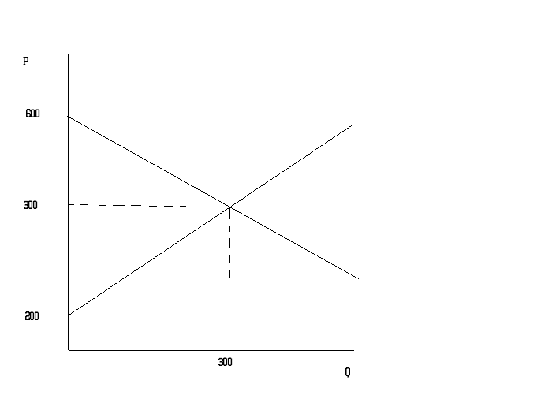

- (4 points) Suppose now that the aggregate income of the individuals that demand the good has increased. This generates a shift in the demand curve of 100 units for every given price. Graph the new demand equation and find the equilibrium price and quantities.
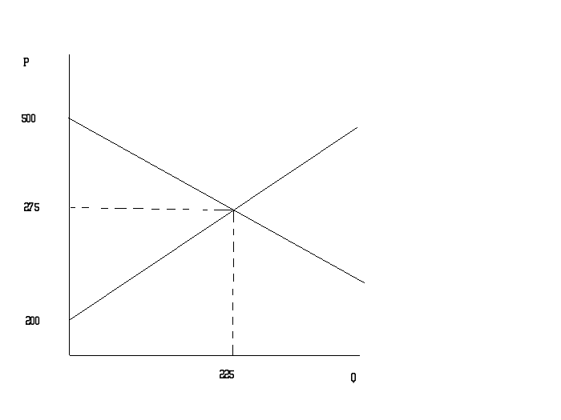
Q=225 and P=275

- (4 points) Find the producer surplus under the first situation. Has the situation of the producers improved or worsened by the aggregate increase of the consumer’s income. (Hint: You may want to compute the producer surplus in part (b) to answer the question or you may be able to answer the question by using a graph to think about what is happening or you may be able to use logic to answer this question.)

The producer surplus in part (a) is $15000. With the change in part (b) we have both the quantity consumed and the price paid decreasing. These two changes imply that the producer surplus must have decreased. A graph or a numerical answer will show the same conclusion.

