Midterm 2 - Afternoon

1. At the equilibrium in the market for bananas, the price elasticity of demand is 0.1 and the price elasticity of supply is 5. A price increase due to a shift in the supply curve would lead to ___________ in total revenue.(For this question assume that the measures of elasticity are constant.)
- an increase
- a decrease
- no change
- an ambiguous change

2. In Mexico suppose the CPI in 1990 is 100 while the CPI in 1995 is 80. This is an example of
- Inflation.
- Deflation.
- Stagflation.
- Calibration.

3. If the price elasticity of demand for car tires is 0.4, and an oil shortage leads to a 10% increase in the price of tires, what do you expect will happen to demand? The quantity demanded will
- Decrease by 40%.
- Decrease by 2.5%.
- Decrease by 4%.
- You cannot tell from the available information what will happen to the quantity demanded.

4. Why might a subsidy program be preferable to a price support program?
- The subsidy program always brings about a smaller deadweight loss than the price support program.
- The costs to the government are always higher when a support program is implemented compared to a subsidy program.
- The producer can always make more sales under the subsidy program than under the price support program.
- There is no storage cost when implementing the subsidy program.

The next 3 questions are based on the following information:

Suppose that the world price of cheese is $2 per pound. The US is a small producer of cheese and its supply is given by P=2Qs. The domestic demand for cheese is given by P=40-2Qd. The quantities in this question are all expressed in millions of pounds of cheese.

5. How many pounds of cheese would be imported into the US if the country opens to trade with the world?
- 19 million pounds
- 18 million pounds
- 17 million pounds
- 16 million pounds

6. Now suppose that the government decides to protect domestic producers and therefore imposes a tariff of $2 per pound of cheese being imported. How much will producer surplus increase by after the imposition of the tariff?
- $1 million
- $2 million
- $3 million
- $4 million

7. The government revenue from the imposition of the tariff is
- $16 million
- $32 million
- $18 million
- $36 million

8. Which of the following statements is necessarily true if the government implements an effective price ceiling?
- The consumer surplus decreases.
- The producer surplus decreases.
- There is no deadweight loss.
- None of above.
New P
Initial P
D
S
S (tax)
B
A
C
New Q
Old Q
Q
P

9. The figure above shows a market in which the government has imposed a tax. Which of the following statements about the graph is correct?
- Rectangle A represents the tax incidence on producers.
- Rectangle B represents the tax incidence on consumers.
- The sum of rectangles A and B represents the government’s revenue from the tax.
- Triangle C represents the government’s tax revenue from the tax.

10. A legal limit on the quantity of a good that can be imported is called an import .
- Tariff.
- Quota.
- Ceiling.
- Floor.

11. For an open economy, an increase in the amount of an import quota in the domestic market leads to:
- An increase in the quantity demanded by domestic consumers relative to the amount demanded with the smaller import quota.
- The total quantity supplied in the domestic market being closer to the equilibrium quantity provided if the domestic economy was a closed economy.
- Less overall production in the market and higher prices than was the case with the smaller import quota.
- Domestic consumers paying a lower price than they did with the smaller import quota, while domestic suppliers earn a higher price than they did with the smaller import quota.

The following three questions use the graph below.
5
7\
10
0
P
Q
0
6
10
D
C
B
0
P
0
NOT TO SCALE

A

20

12. On the demand curve shown above identify which point has the highest price elasticity of demand
- A
- B
- C
- D

13. Suppose a business was facing the demand curve shown above. Which of the above points would they choose to maximize their total revenue?
- C.
- B.
- D.
- None of the above.

14. Suppose the business raised prices, but found that revenue went down. This result could be represented as a movement
- From point A to point B.
- From point B to point C.
- From point A to point D.
- None of the above.

The next 3 questions are based on the following information:

Consider the city of Madison. Let the demand for movie tickets be given by P = 30 – 2Qd. Let the supply for movie tickets be given by P = Qs. The city government decides to impose an excise tax of $3 on sales of movie tickets.

15. What is the equilibrium net price that producers will get for selling their good (this is the price producers receive after the tax has been deducted)?
- $12
- $9
- $10
- $6

16. How much is the deadweight loss due to the imposition of the excise tax?
- $ 1
- $ 1.5
- $ 2
- $ 3

17. How much money does the city of Madison collect as the tax revenue when they impose the excise tax?
- $10
- $6
- $27
- $9

18. Which of the following statements is false? The imposition of a tariff on imported cars will lead to
- Increased domestic production of cars.
- The price of domestic cars being lower than the price of imported cars.
- Reduced domestic demand for cars.
- Fewer domestic purchases of imported cars.
A
B
milk
cheese

19. The above picture shows the indifference curves and the budget line for Jennifer. If her income goes down she moves her optimal consumption from point B to point A. Which of the following statements is true?
- Milk is a normal good.
- Cheese is an inferior good.
- Cheese is a substitute good.
- Milk is an inferior good.

20. Suppose Columbia is a small country that is currently closed to the world trade in coffee. The Columbian domestic demand for coffee is Q=4.4-P and the domestic supply of coffee is Q=3P+0.4. Suppose right now, Columbia decides to join the world trade in the coffee market. If the world price of coffee right now is $4 per pound, what will happen in Columbia after it opens its domestic coffee market to world trade? Columbia will
- Import 12 units of coffee.
- Find its domestic price of coffee decreases when it engages in open trade in the coffee market.
- Export 12 units of coffee.
- Find its domestic consumer surplus increases when it engages in open trade in the coffee market.

Consider the graph below for the next question

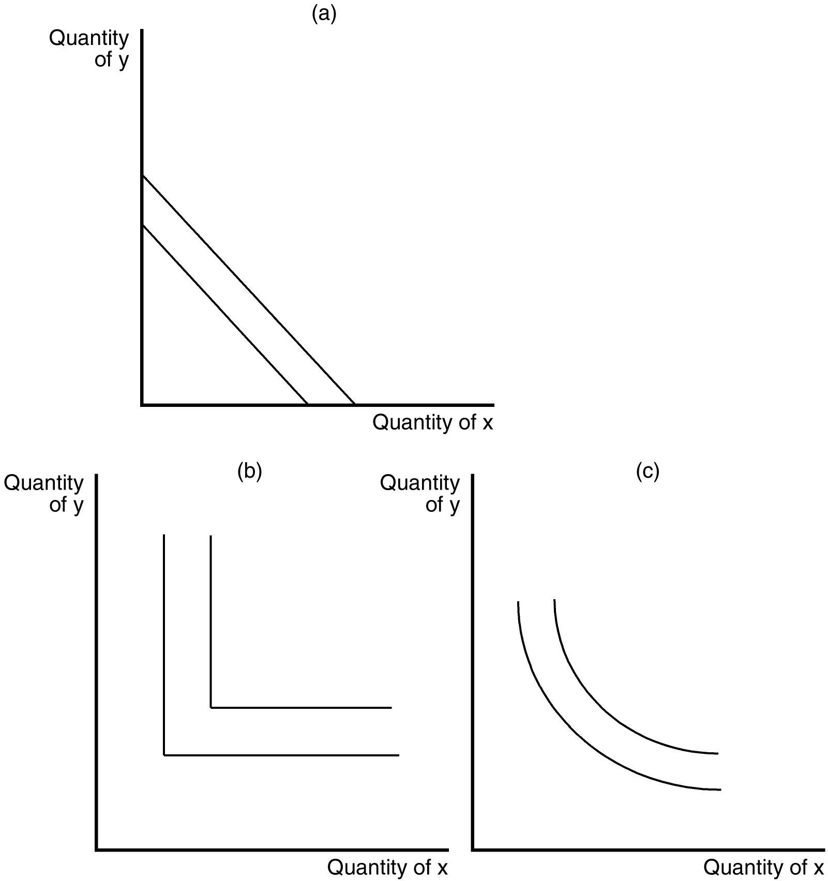

21. In the figure directly above, which of the graphs shown represent indifference curves for perfect complements?
- graph (a)
- graph (b)
- graph (c)
- None of the above.

22. In the US, suppose the CPI in 2000 is 110 while the inflation rate between 2000 and 2004 is 10%. What is the measure of the CPI in 2004?
- 131
- 121
- 141
- 126

The next THREE questions are based on the following: John has $100 in income, and consumes two goods, X and Y. The price of X is $5 and the price of Y is $4. Assume good X is measured on the horizontal axis and good Y is measured on the vertical axis if drawing any diagrams.

23. The equation for John’s budget line is:
- 5X+4Y=100.
- 4X+5Y=100.
- X+Y=100/(4+5).
- X+Y=100.

24. Which of the following points could never be an optimal bundle for John given the above information?
- (X,Y)=(20,0)
- (X,Y)=(0,25)
- (X,Y)=(12,10)
- (X,Y)=(10,12)

25. If John’s optimal bundle is at (X,Y)=(8,15), then the slope of his indifference curve at this bundle is:
- -8/15
- -15/8
- -5/4
- -4/5

26. In the US, suppose the CPI in 1990 is 100 while the CPI in 1995 is 120. What is the inflation rate between 1990 and 1995?
- 2%
- 20%
- 120%
- 200%

Use the following information to answer the next two questions:

Katerina is trying to decide what quantity of soda and beer she will consume.
Soda costs $1 per bottle, beer $2 per bottle. The income of Katerina is $9. The marginal utilities (MU) of Katerina from the consumption of different quantities of these drinks are as follows:

Units of good | MU of soda | MU of beer
1 | 10 | 50
2 | 9 | 40
3 | 8 | 30
4 | 7 | 20
5 | 6 | 16

27. The feasible combination of the two drinks that maximizes Katerina’s total utility, assuming Katerina spends her entire income, is:
- 3 bottles of soda, 3 bottles of beer
- 1 bottle of soda, 4 bottles of beer
- 1 bottle of soda, 2 bottles of beer
- 3 bottles of soda, 5 bottles of beer

28. The total utility measured in utils (where utils is a measure of the amount of utility an individual receives when consuming a good) that Katerina receives at the optimal consumption bundle is:
- 247 utils
- 70 utils
- 150 utils
- 105 utils

29. Consider the computer market in a small country, IT Country. In the domestic market, the equilibrium price is $500 and the equilibrium quantity is 100. This country starts to trade in the world market, and the world price is $200, so they must import computers. 4 economists offer the following statements. Which statement is correct?
- Economist A: In our country, the Demand Curve for computers is elastic (not perfectly) and the Supply Curve is inelastic, so the consumer surplus is small. Thus, if we were to impose a tariff, our total surplus for IT Country in the computer market would increase relative to the total surplus with open trade.
- Economist B: Our country should start to export computers. Thus, we should use a tariff of $400 per computer so that we can become computer exporters.
- Economist C: If our goal is to maximize the total surplus for IT Country in the computer market, we should not use trade protection measures even if some domestic computer companies go bankrupt.
- Economist D: If the demand curve shifts left, the quantity demanded will increase. As a result, the domestic production will increase.

Use the graphs below to answer the following question.
P
Q
D₁
P
Q
P
Q
D₂
P
Q

30. Based on what you know about relative elasticity, which set of descriptions are the best fit for the demand curves shown above?
- D1: Demand for gasoline when the time period for adjustment is 1 week. D2: Demand for gasoline when the time period for adjustment is 1 year.
- D1: Demand for pain relief medicine. D2: Demand for Advil, which is a specific brand name for pain relief medicine.
- D1: Demand for food. D2: Demand for sailboats.
- D1: Demand for Tide brand laundry detergent. D2: Demand for laundry detergent.

Answers
1a 2b 3c 4d 5b 6c 7b 8b 9c 10b 11a 12d 13b 14b 15b 16b 17c 18b 19a 20c 21b 22b 23a 24d 25c 26b 27b 28c 29c 30d

