First Midterm 02.23.2006 Prof. Kelly Econ 101

Use the following graph to answer the next three questions.

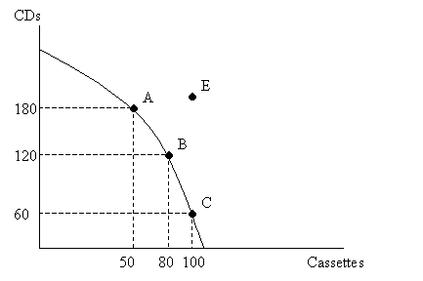
1. The above figure shows the PPF for a music processing plant that produces both CDs and cassettes. Between points B and C, the opportunity cost of one cassette is:
- 10 CDs
- 20 CDs
- 15 CDs
- 3 CDs

2. Which of the following is definitely attainable for the plant given ONLY the information from the picture.
- 120 CDs and 90 cassettes.
- 179 CDs and 49 cassettes.
- 170 CDs and 80 cassettes.
- 119 CDs and 100 cassettes.

3. Which of the following is TRUE given ONLY the information from the picture?
- It is possible for the plant to produce at point E.
- At point A, the plant is under-utilizing its resources.
- As the plant produces more and more CDs, it must give up an increasing amount of cassettes.
- The opportunity cost of producing CDs is constant for this firm.

4. What happens to a nation’s imports or exports of a product when the world price of the product rises above the domestic price? Holding everything else constant,
- Imports of the product increase.
- Imports of the product stay the same.
- Exports of the product increase.
- Exports of the product decrease.

5. Joe usually buys 4 hamburgers at his favorite fast food place. However, today he discovers that the price has changed from $1 per hamburger to $1.40 per hamburger. He responds by buying only 2 hamburgers. What can we say about his price elasticity of demand for hamburgers?
- Joe’s demand is inelastic, causing him to spend less money on hamburgers than before.
- Joe’s demand is inelastic, causing him to spend more money on hamburgers than before.
- Joe’s demand is elastic, causing him to spend less money on hamburgers than before.
- Joe’s demand is elastic, causing him to spend more money on hamburgers than before.

6. Assume that petroleum and natural gas are substitutes for each other. Holding everything else constant, if the price of petroleum increases, then in the market for natural gas:
- the equilibrium quantity will increase and the equilibrium price will decrease.
- the equilibrium quantity will change in an ambiguous way and the equilibrium price will increase.
- the equilibrium quantity will decrease and the equilibrium price will change in an ambiguous way.
- the equilibrium quantity will increase and the equilibrium price will increase.

7. Holding everything else constant, when a tariff is imposed on a good imported from abroad,
- the domestic quantity supplied increases.
- the domestic quantity supplied decreases.
- the foreign quantity supplied increases.
- Both (a) and (c)

Use the following information to answer the next three questions.

A small village, Djose, produces and consumes only one good, blitz ball. Their domestic demand curve for blitz ball is given by the equation: P = 200 – 2Q. The domestic supply curve for blitz ball is given by the equation: P = 50 + Q. The equilibrium world price is currently at $70.

8. Given the above information, if Djose opens to trade with the world, which of the following statements is true?
- The domestic price will still be at $50.
- The world price will fall to $50.
- Djose village will export 45 blitz balls.
- Djose village will import 45 blitz balls.

9. Suppose that Djose village is open for international trade. What will happen if Wakka, a leader of Djose village, decides to impose a tariff of $20 on each blitz ball imported? Holding everything else constant,
a. The new equilibrium domestic price will be at $70.
b. After imposition of the tariff, no international trade occurs.
c. Djose village will export 15 blitz balls.
d. Djose village will import 15 blitz balls.

10. Disregard the information provided in the preceding question.. Suppose that Djose village is open for international trade. What will happen if Wakka decides to impose an import quota limit of 50 blitz balls? Holding everything else constant,
- The new equilibrium domestic price will be at $80.
- Djose village will import 45 blitz balls.
- Djose village will import 50 blitz balls.
- Djose village will export 50 blitz balls.

11. Nations use barriers to international trade (tariffs and/or quotas) to benefit the economic positions of __________. These barriers __________ economic efficiency and trade among nations.
- consumers/ increase
- consumers/ decrease
- domestic producers/ increase
- domestic producers/ decrease

12. Joe consumes two goods, potatoes and pasta. Holding everything else constant, when Joe’s income increases, he buys less potatoes and more pasta. Which of the following is correct?
- Pasta and potatoes are complements.
- Pasta and potatoes are substitutes.
- Pasta is an inferior good.
- Potatoes are an inferior good.

Use the information displayed in the graph below to answer the next question.

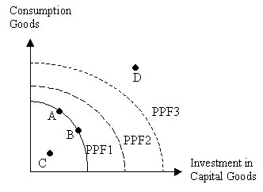

13. PPF1 represents a Production Possibility Frontier of a country today on which two points A and B are indicated. Two additional points, C and D, are also marked on the above graph. PPF2 and PPF3 represent the possible Production Possibility Frontiers of the country’s economy ten years from now. The economy is more likely to have the production possibilities described by curve PPF3 instead of PPF2 if today the economy chooses:
- Point A on PPF1.
- Point B on PPF1.
- Point C inside PPF1.
- Point D outside PPF1.

14. Consider the wooden table market. Suppose that the price of wooden chairs increases and simultaneously the price of wood decreases. The equilibrium price in the market for wooden tables will ____ and the equilibrium quantity will ________.
- fall, not be determined
- rise, not be determined
- not be determined, rise
- not be determined, fall
15. Both Maryland and Wonderland produce DVDs and hard disks with each country having linear PPFs and the same level of resources. Maryland has a comparative advantage over Wonderland in producing DVDs. Which of the following statements is true?
- The opportunity cost (O.C.) of producing 1 unit of DVDs is lower in Maryland than in Wonderland and also the O.C. of producing 1 unit of hard disks is lower in Maryland than in Wonderland.
- The opportunity cost of 1 unit of DVDs is lower in Maryland but the O.C. of 1 unit of hard disks is lower in Wonderland.
- The O.C. of 1 unit of DVDs is lower in Wonderland and the OC of 1unit of hard disks is also lower in Wonderland.
- The OC of 1 unit of DVDs is lower in Wonderland and the OC of 1 unit of hard disks is lower in Maryland.

16. Which of the following is a positive statement?
- The dollar witnessed a rise of 0.8 % versus the Euro yesterday.
- The European Union should lower farm subsidies to ensure fair play in the international agricultural market.
- People must think at the margin.
- Taxation should be eliminated for the good of the economy.

Use the following information to answer the next two questions.

Suppose the apple market demand is Q_{D} = -0.5P + 5 and the apple market supply is Qs = 2P.

17. Find the equilibrium price (P) and quantity (Q).
- P=4, Q=4
- P=2, Q=2
- P=4, Q=2
- P=2, Q=4

18. If the price is not determined by market forces but is simply set at $1, then
- There will be a shortage of 2.5 apples in the market.
- There will be an excess supply of 2.5 apples in the market.
- There will be a shortage of 5 apples in the market.
- There will be an excess supply of 5 apples in the market.

19. Suppose that demand for coconuts is given by the equation: Q_{s} = 8 – 2P_{s}. Using the point-slope method, calculate the elasticity of demand when the price equals 2.
- 1/4
- 1/2
- 1
- 2

Use the following information to answer the next two questions.

Waterland and Parkland produce Pens and Markers. They use the same level of resources and have straight line PPFs. The following points describe the PPF for the two islands:

Waterland Parkland

Pens | Markers
800 | 0
0 | 400
Pens | Markers
900 | 0
0 | 600
20. Which of the following statements is true about the absolute advantage in producing Pens and Markers.
- Waterland has an absolute advantage over Parkland for producing pens.
- Waterland has an absolute advantage over Parkland for both pens and markers.
- Parkland has an absolute advantage over Waterland for both Pens and Markers.
- Neither of them have an absolute advantage over the other for Pens.

21. Which one of the following statements is true of Waterland and Parkland production if the two countries begin to trade?
- Waterland would be better off producing only Pens and trading.
- Parkland would be better off producing only Pens and trading.
- Parkland can not be made better off through trade.
- Waterland and Parkland should make the same number of Markers.

22. If demand is perfectly elastic and supply is unit elastic, then the burden of an excise tax on suppliers will ___________.
- fall mostly on suppliers.
- fall mostly on consumers.
- fall entirely on suppliers.
- fall entirely on consumers.

23. Assume that oranges are an input to the orange juice production and that oranges and orange juice are substitute goods in consumption. Holding everything else constant, if the price of oranges rises, the equilibrium price of orange juice will ______ and the quantity of orange juice that is supplied will _____
- rise , rise
- fall , fall
- rise, change in an ambiguous manner
- rise, fall

24. Under which of the following assumptions would an increase in the price charged by firms lead to an increase in total revenue collected by firms?
- Supply is elastic.
- Supply is inelastic.
- Demand is elastic.
- Demand is inelastic.

Use the following information in answering the next three questions.

The demand for guitars is given by: P_{d} = 60 – 2Q_{d}.
The supply of guitars is given by: P_{s} = Q_{s}.
Suppose that an excise tax of $9 is placed on the producers of guitars.

25. What is the new equilibrium price (P) and quantity (Q) in the market for guitars after the imposition of the tax?
- P=26, Q=20
- P=17, Q=26
- P=20, Q=10
- P=26, Q=17

26. What is the amount of tax revenue generated from this tax?
- $90
- $180
- $140
- $153

27. Which of the following statements is true?
- The incidence of the tax falls mainly on consumers.
- The incidence of the tax falls mainly on producers.
- The incidence of the tax falls equally on consumers and producers.
- More information is needed to determine the relative tax incidence.

Use the information displayed in the graph below to answer the next three questions.

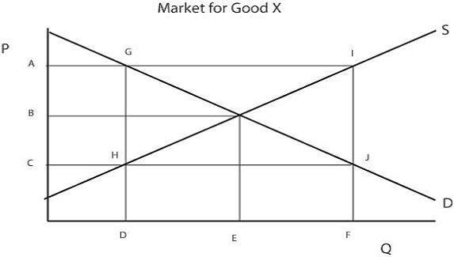

28. Suppose the government wishes to set a price at A using a price support. Which of the following rectangles represents the amount of money they will need to spend on good X to achieve this price?
- GHJI
- AGHC
- HJFD
- GIFD

29. Now suppose that the government will use a price subsidy to achieve price A. Which rectangle represents the amount of money the government will pay in subsidies?
- AIJC
- AGHC
- HJFD
- GIFD

30. Imposing a price floor at Price A will cause:
- A shortage of (F-E) units.
- A shortage of (F-D) units.
- A surplus of (F-E) units.
- A surplus of (F-D) units.

Use the following information to answer the next two questions.

Consider the cheese market in Wisconsin. The demand for cheese is given by P = 90-Qd. The supply for cheese is given by P = 2Qs.

31. Suppose that the government sets a price floor at $80. After the introduction of the price floor consumer surplus will decrease by _____ and there will be ____ Dead Weight Loss in the market for cheese.
- 100; no;
- 200; some;
- 300; no;
- 400; some

32. Now, suppose further that the government has a storage cost equal to $20 per unit. What is the total cost from implementing a price support program at $80?
- $2400
- $3000
- $4800
- $5000

33. In order to have any effect at all in a market, a price ceiling in that market must be set _______the equilibrium price.
- at
- above
- below
- above or below

Answers:
1d,2b,3c,4c, 5c, 6d, 7a, 8d, 9d, 10b, 11d,12d, 13b, 14a, 15b, 16a, 17d, 18a, 19c, 20c, 21a, 22c, 23c, 24d, 25d, 26d, 27a, 28d, 29a, 30d, 31d, 32b, 33c

